Exploring the topic of
Immigration
In a 10th grade Social Studies class:
A Multi-genre Approach
SLM 504
Spring 2011

By
Kate Castle, Sherry Reed, Lisa Tipton, and Stacia Wells

Resource #1

http://www.archive.org/details/Immigrat1946 Internet Archive Website
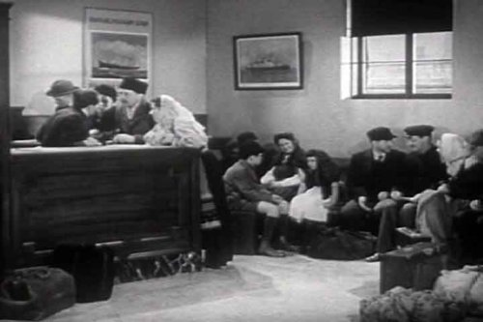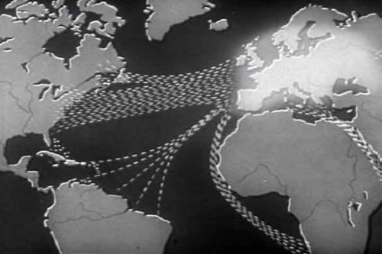
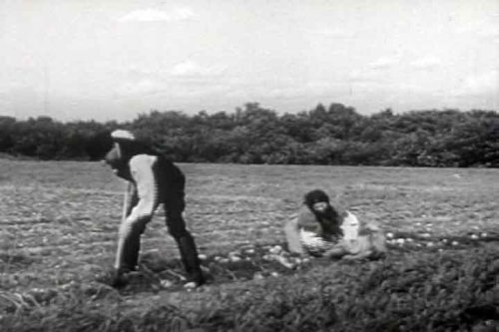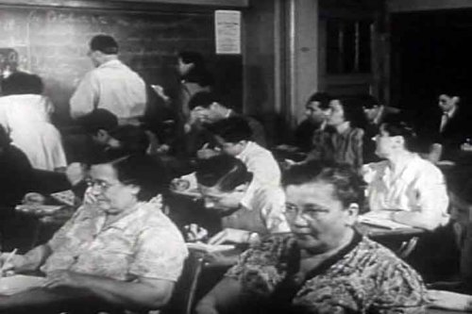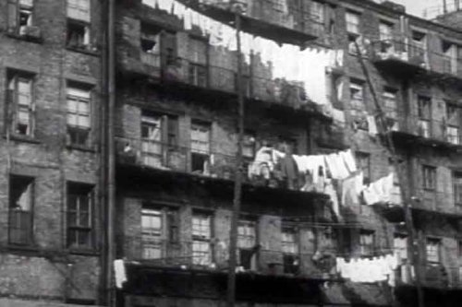
Archives, Internet. Immigration (1946). 1996. April 2011 <http://www.archive.org/details/Immigrat1946>.
Summary:
Film produced in 1946 includes actual footage from Ellis Island as well as maps of immigration flow and reenactment of immigrants’ experiences. Provides immigration history of the United States, including the passing of the 1924 bill that severely restricted new immigrants from gaining citizenship. Explains some of the economic, religious, and political motivation for immigration. Told from the perspective of the time period (1940’s), this video gives students the opportunity to learn not just about the early history of immigration in this country, but to experience first-hand the attitudes about this subject as seen through the unfiltered lens of 1940’s America. Unique classroom experience.

Teaching Strategies:
- Students can discuss/write about similarities and differences between attitudes about immigrants during the 1940’s and today. How has it changed, stayed the same?
- Research possibilities: Compare experiences of early 1900’s immigrants to the recently emigrated. Which countries/world regions produced the most immigrants to the U.S. then and now?
- Group work: Have students consider the effects on immigrants of the process then and now. How has it changed? Stayed the same?
- Discussion topics: What makes someone a United States citizen? Are we a nation of foreigners? What does that mean to our sense of unity as a country?

Resource #2

Tan, Shaun. The Arrival. New York: Arthur A. Levine, 2006.

Summary:
This wordless graphic novel allows readers to experience firsthand the hardships that immigrants encountered. Leaving his family behind, the protagonist arrives in a new world looking for a better life with the hope that his family will one day join him. He struggles to find a place to live, a job, and his niche in the world. Everything he encounters is unfamiliar – the food, the people, the customs, and the language. As time passes, the protagonist meets fellow immigrants and learns from their stories and experiences.

Teaching Strategies:
- Using teacher selected pages, students will write dialogue for the accompanied illustrations to tell the immigrant’s story.
- Create a journal written from the protagonist’s point of view
- Select a ‘photo’ (from the front or back inside cover) and write a story describing the person’s experiences during his/her journey to the new world and the experiences once he/she arrived.
- Select a ‘photo’ (from the front or back inside cover) and create a passport for this person.

Resource #3

Bausum, Ann. Denied, Detained, Deported: Stories from the Dark Side of American Immigration. National Geographic Children, 2009.

Summary:
Many people know of the success stories of immigration. In this text Bausum explores the dark side of immigration, one filled with despair, fear, and sorrow. The book chronicles the lives of those who experienced the horrors of immigration, more specifically those who were denied entry into the United States, detained against their will, or deported back to countries where their lives would come crashing down. These were their lives, and these are their stories.

Teaching Strategies:
- Select passages from each of the 3 types of immigration stories that share something in common. In groups of 3, assign each student a different excerpt to read and take down notes by using a teacher generated worksheet. Students will then share the information about the excerpt that they read and make a poster to compare/contrast the types of experiences.
- Assign the class a short excerpt from one person’s immigration story. Students will be assigned to write a journal/diary entry from the point of view of the person in the excerpt. This assignment can be given out a few times throughout the text, one time for each type of immigration story.
- Mini Research Unit: Assign the chapter on Japanese Internment Camps. Teacher will also give students a few resources on the Holocaust to read through and take notes. Students will complete an assignment of teacher’s choice (poster, short paper, class discussion) comparing the Holocaust to the time of Japanese Internment.

Resource #4
Na, An. A Step from Heaven. New York: Speak, 2001.
Summary:
A Step From Heaven is a National Book Award finalist and the 2002 Michael L. Printz award winner. Constructed as a series of vignettes, this novel paints the incredibly colorful and broad swath of Young Ju Park’s immigration from Korea to Mi Gook (America). Realistic fiction, the vignettes span fourteen years, beginning in Korea just before four year-old Young Ju finds out her family is moving to magical America, and continues through the family’s entire transformation of immigration and acclimation, culminating in Young Ju’s graduation from American public high school. The heavy themes of cultural acclimation, language and cultural barrier, the arduous immigration process, and the effects of both alcohol and physical abuse, are treated with a beautiful, deft and lean pen.

Teaching Strategies:
- Geographical: Much is made of the differences in the neighborhoods and structures in the book. Using the textual clues and descriptions as well as their imaginations, students will collaborate in pairs to render a map-mural of Young Ju’s “world” in Southern California, noting all of the places she lives, the library, her “fake house,” her school, etc, and their relationship to each other. Each site will have a description of its events in the book, what it might represent on a metaphorical level and its importance to Young Ju’s growth as a character.
- Gastronomical: Variation in foods is an important way that An Na illustrates Young Ju’s immigration process, and her “Americanization.” The traditional Korean food of rice, in many forms, appears throughout the book. Students will use a “grains of rice” graphic organizer to chart the scenes where Korean food is mentioned and how it functions for the characters. Students will then brainstorm for Western equivalents to these dishes, doing research if necessary. Example: “Joon and Young Ju feed the sick bird, Harry, “juk-rice” to comfort him…what is a comfort food you have been given when you are sick?” Finally, each student will write a “recipe card” for a specific conflict a character encounters in the book.
- Immigration Process: The actual process for obtaining U.S. citizenship is arduous, and partially described in the book, in the green card vignette. Students will work in small “green card” groups to research the legal and procedural steps in the naturalization process, and present their understanding of the process in a multimedia project for the class. Students will be asked to compare and contrast immigration to a personal process from their own lives, such as the process of obtaining a learners’ permit to drive, or the separation and divorce process of parents.

Resource #5

Scholastic Website: http://teacher.scholastic.com/activities/immigration/
Webpage: Stories of Yesterday and Today: Immigration

Ellis Island Guided Tour: Various related applications
Continue the journey: 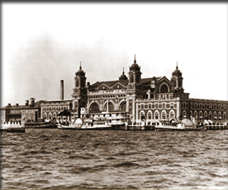
Scholastic. Immigration: Stories of Yesterday and Today. 2011. April 2011 <http://teacher.scholastic.com/activities/immigration/index.htm>.

Summary:
Scholastic is a global children's publishing, education and media company and its website features a section on immigration. Visitors to this page can take a virtual tour of Ellis Island complete with accompanying facts about each stage of the process. Webpage links/related activities include an application that lets students create their own graphs/charts using information about their own and classmate’s immigration background.

Teaching Strategies:
- Have students take virtual tour of Ellis Island then create own immigrant character and write story about his/her experience coming to America based on what they have learned from watching the visual tour.
- Take a survey of class members and use the website application to create chart/graph showing diversity of the class. Based on the findings, discuss suppositions about larger patterns in the population.
- Have students go on a web quest, a scavenger hunt type of activity in which students explore a website with specific features in mind and complete associated worksheet/assignment.
- End of unit discussion/project: Connect the different sources used/studied in this unit in some of the following ways: common themes, common experiences, similarities and differences between the process/experience of immigration in the early 1900’s and today.

Bibliography

Archives, Internet. Immigration (1946). 1996. April 2011 <http://www.archive.org/details/Immigrat1946>.

Bausum, Ann. Denied, Detained, Deported: Stories from the Dark Side of American
Immigration. Washington, D.C.: National Geographic, 2009.

Na, An. A Step from Heaven. New York: Speak, 2001.

Scholastic. Immigration: Stories of Yesterday and Today. 2011. April 2011 <http://teacher.scholastic.com/activities/immigration/index.htm>.

Tan, Shaun. The Arrival. New York: Arthur A. Levine, 2006.

Professional Resources

Booklist (June 1, 2001, Sept. 1, 2007, April 15, 2009)
Horn Book (Fall 2007, Fall 2009)
Kirkus Review (Sept. 1, 2007, April 1, 2009)
Library Media Connection (Nov/Dec. 2007, Nov/Dec. 2008)
School Library Journal (May 1, 2001, May 1, 2009)
V.O.Y.A.

