Lisa Tipton
SLM 552

Program Assessment

When discussing this project with my school librarians, it became clear that there were a few aspects of their program that they wanted to evaluate. In the end, I wanted this assignment to be something that would truly help/be directly applicable to their goals for next year. Therefore, we decided to focus on two specific pieces of the media center, the usage of a new database as well as hours of media center operation.

When designing my evaluative tools, I consulted Maryland Standards for School Library Media Programs, Empowering Learners, Howard County’s Library Media Program Vision Statement, as well as Reservoir High School’s Media Center Vision and Mission Statements. Included below are excerpts from these resources that align with my evaluative tools.

Standards for School Library Media Programs in Maryland:

Standard 5.0- Resources and Resource Services

The school library media program is organized to provide flexible and equitable access to
resources and resource services for students and staff.

5.01.02- include print and electronic resources that are selected and evaluated in
accordance with local school system policies
5.02.03- encourage the use of instructional materials and technologies by students and
staff.
5.02.04- support the total curriculum of the school.

Empowering Learners

VI. Collection and Information Access

Guideline: The school library media program includes a well-developed collection of books, periodicals, and non-print material in a variety of formats that support curricular topics and are suited to inquiry learning and users’ needs and interests.

- maps the collection to ensure that it meets the needs of school curriculum
- collaborates with the teaching staff to develop an up-to-date collection of print and
digital resources in multiple genres that appeals to differences in age, gender, ethnicity,
reading abilities, and information needs
(Empowering Learners 38)
Howard County Library Media Program Vision Statement:

“The mission of the Howard County School Library Media Program is to provide opportunities for students and staff to become effective users of ideas and information.”

“The collections of the library media program are developed and evaluated collaboratively to support the school's curriculum and to meet the diverse learning needs of students.”

Objectives for the Library Media Specialist:

* Maintain current and comprehensive knowledge of the curriculum, of students'
characteristics and needs, and of instructional and informational resources in the full
range of formats and topic areas.
* Develop and direct a continuous collection development and evaluation process.
* Maintain and use a variety of appropriate, up-to-date tools and techniques to locate
and select materials.

“Access to the full range of information resources and services through the library media program are fundamental to learning.”

Objectives for the Library Media Specialist:

* Evaluate, acquire, provide, and promote information resources to meet the learning
needs of all learners.

Reservoir High School’s Media Center Vision/Mission Statement

“The mission of our Media Program is to provide opportunities for students and staff to become effective users of ideas and information. We strive to assist students and staff to reach the highest level of independence in locating and using information and technologies. We respect patrons as individuals and assist each one according to her or her needs.”

Evaluative Tool 1:

The following survey was sent out to assess the first element that the school librarians wished to know more about, the usage of the new database Facts on File: Bloom’s Literary Reference Online.

As the database is directly applicable to the English Curriculum, the survey was sent out to the entire English Department (16 people). The school librarians wanted to know how many people had simply viewed/used the database during this school year. The results will help them address issues such as if they need to advertise the database more, or host an in-service to showcase its features.

As the survey is copied from Google Forms, it will take up the space of 2 pages in this Word Document.

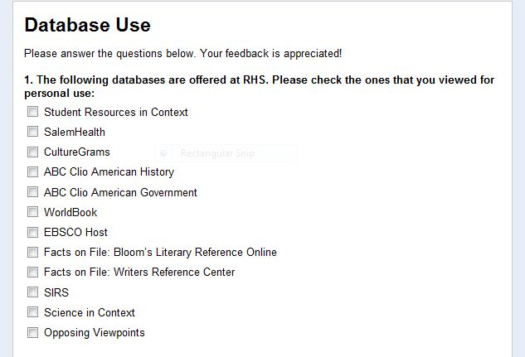

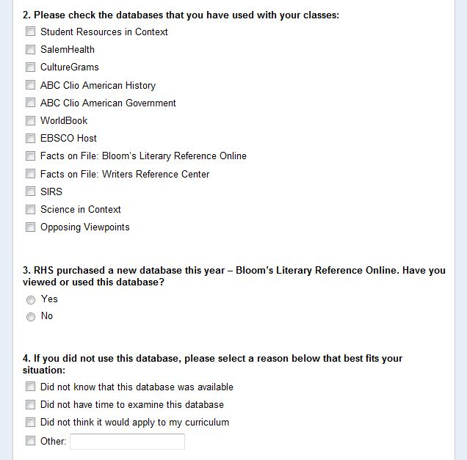

The librarians knew that two teachers utilized Bloom’s Literary Reference Online with their classes. I therefore created two evaluative tools, one for the teachers, and one for the students. The survey was taken by 53 students. The data from this tool will help the school librarians to see what students and teachers found to be the benefits and weak features of the database. This information can help the librarians to know what beneficial features to highlight to teachers during the upcoming school year.

The surveys below are copied from GoogleForms.

Teacher Evaluative Tool:

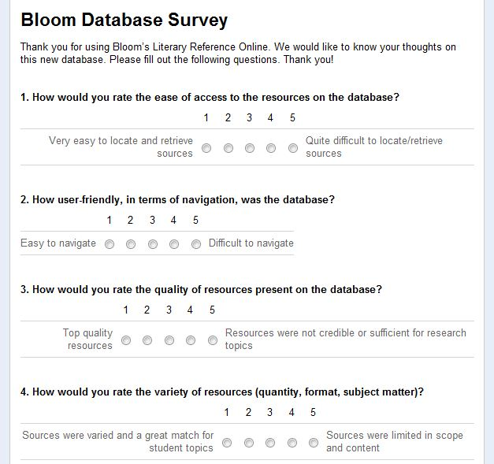

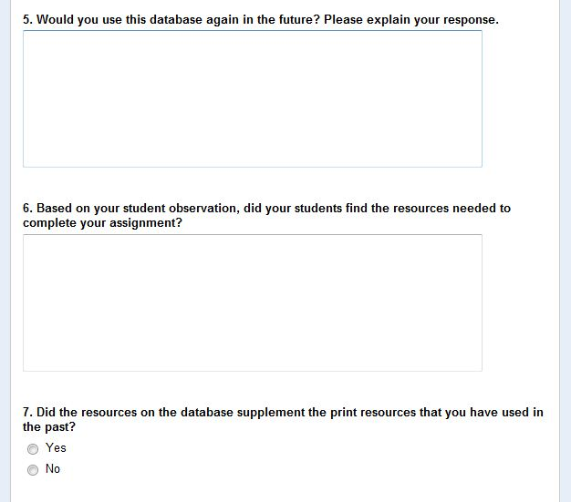
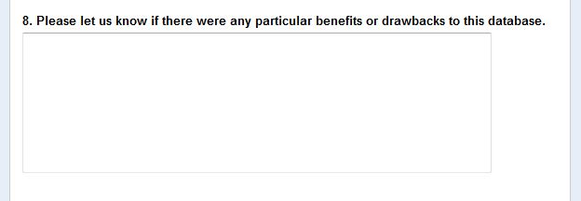

Student Evaluation:

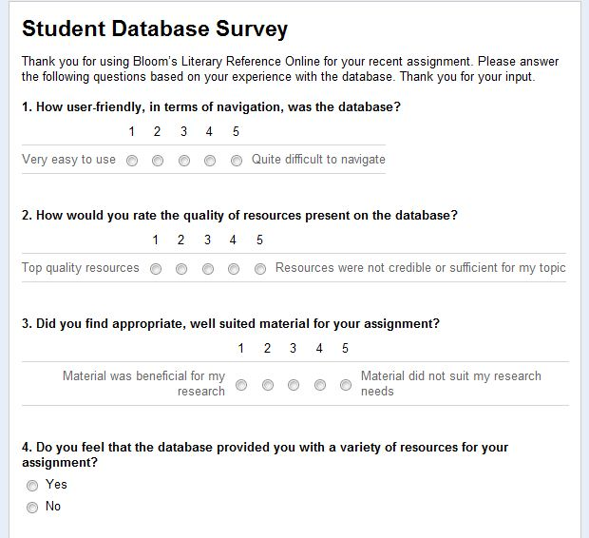
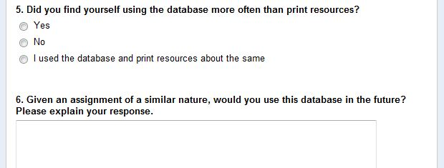

Evaluative Tool 2: Media Center Hours of Operation

Standards for School Library Media Programs in Maryland:

Standard 2.0- Goals and Objectives

The school library media program has written goals and objectives related to the school
library media program mission statement.

2.11- provide equitable and timely access to an organized, diverse collection of quality
instructional materials

Standard 4.0- Staffing

An effective school library media program requires certified library media specialists and
adequate support staff with appropriate skills.

4.01- ensures that all students in every school have access, on a regular basis, to certified
library media personnel.

Standard 5.0- Resources and Resource Services

The school library media program is organized to provide flexible and equitable access to
resources and resource services for students and staff.

5.02.01- allow on-site access to knowledge and information.
5.02.05- promote the school library media program to students, staff, parents, and the
community.

Empowering Learners

III. The Learning Space

Guideline: The school library media program includes flexible and equitable access to
physical and virtual collections of resources that support the school curriculum and meet the diverse needs of all learners.

- ensures library hours provide optimum access for learners and other members of the
school community.

(Empowering Learners 33)
Howard County Library Media Program Vision Statement:

“The mission of the Howard County School Library Media Program is to provide opportunities for students and staff to become effective users of ideas and information.”

“The library media program provides physical access to information and resources for learning.”

Objectives for the Library Media Specialist:

* Encourage flexible access to the programs and services of the library media
program.

“The library media program offers flexible and equitable access to information, ideas, and resources for learning.”

Objectives for the Library Media Specialist:

* Work collaboratively with the learning community to develop and implement
policies and practices that make resources, facilities, and professional assistance
available at the time of learning.
* Maintain an environment that meets the informational needs of all students and
teachers.
* Encourage the widest possible use of program resources and services.

Reservoir High School’s Media Center Vision/Mission Statement

“The mission of our Media Program is to provide opportunities for students and staff to become effective users of ideas and information. We strive to assist students and staff to reach the highest level of independence in locating and using information and technologies. We respect patrons as individuals and assist each one according to her or her needs.”

The following survey was sent out to assess the second element that the school librarians wished to know more about, the possibility of extending Media Center Hours.

The survey was sent out to all administrators (5 people), as well as all Instructional Team Leaders in the building (11 people). The librarians first wanted to see what this group of people thought about the idea. Pending the responses of this survey, the librarians will then decide if they will survey students as well as school community members to see if the library should have extended hours.

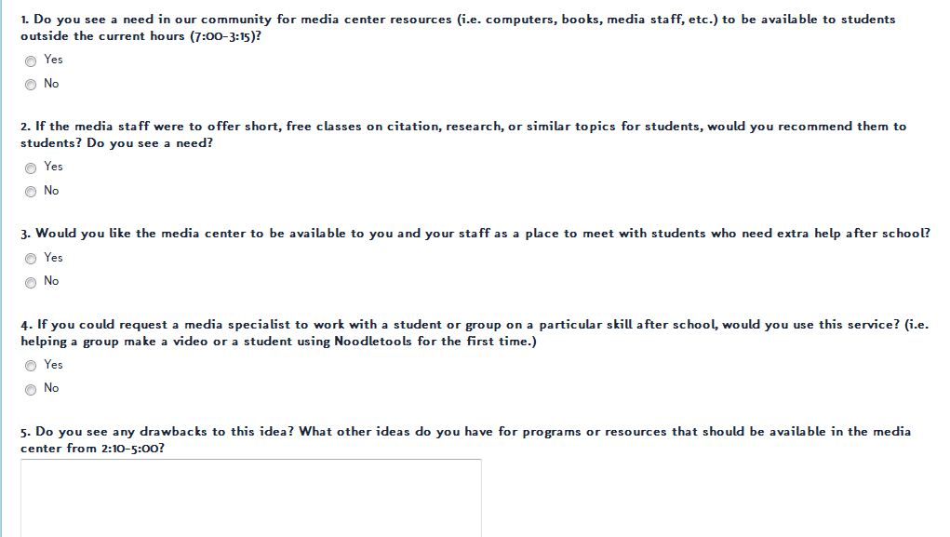

Evaluative Tool Summary:

Bloom’s Literary Criticism Evaluation Tools:

Survey 1: English Department (16 people) Responses yielded: 12

Question 1: Responses indicated that 8 people use SIRS, 5 people use EBSCO Host,
4 people use Opposing Viewpoints, 2 people use Student Resources in
Context, 1 person uses Bloom’s Literary Reference Online

Question 2: Responses indicated that 7 people use SIRS with their classes, 3 people use
EBSCO Host with their classes, 6 people use Opposing Viewpoints with their
classes, 2 people use Student Resources in Context with their classes, 2
people use Bloom’s Literary Reference Online with their classes

Question 3: Only 2 people have viewed or used Bloom’s Literary Reference Online

Question 4: 7 people did not know that Bloom’s was available for use, 3 people
indicated that they did not have time to look at the database this year, 1
person believed it wouldn’t fit his/her curriculum, 1 person wrote in that
they would prefer to find sources on Google

The results from this survey indicate that this database was not utilized to its full potential this school year. In trying to discover why this is the case, the most telling question was #4—people simply did not know that the database existed. This information tells me that the database was not advertised enough, thus teachers did not know to use it as a resource. If I were the media specialist, I would invite the English Department to an in-service exploring the features and benefits of this database. If an in-service is held, teachers will clearly see that this database, which was purchased by the school instead of the county, aligns beautifully with their curriculum. I would then try to meet with individual teachers in hopes of creating an assignment that requires students to use the database as their means of research. By informing the teachers that this resource exists and is well suited for their curriculum, the database should finally be used as my librarians hoped it would be. While the main focus of this tool was to see if the new database was being used, it also reveals the use of other databases at the school. This information can be used in the future to address these databases in order to increase their usage as well.

Survey 2: Teacher Evaluation of Bloom’s Reference Online (2 people) Responses yielded: 2

How would you rate the ease of access to the resources on the database?
Both teachers ranked this as #1- Very easy to locate and retrieve resources

How user-friendly, in terms of navigation, was the database?
Score of 1 and 2- Easy to navigate

How would you rate the quality of resources present on the database?
Scores of 1 and 2 with 1 being Top Quality Resources

How would you rate the variety of resources (quantity, format, subject matter)?
Scores of 2 and 3 with 1 being Sources were varied and a great match for student topics
and 5 being Sources were limited in scope and content

Would you use this database again in the future? Please explain your response.
One teacher wrote “I will use this again. This database delivered many high-quality
sources to the students, and it made it easier for the students to read and determine if
the source helped with their thesis statements. In the past the students spend so much
time locating sources that they did not sufficiently evaluate what they had. Since they
found quality sources relatively quickly, they had more time to evaluate the source and
determine its relevance to their thesis.”
The second teacher wrote, “I would use this again, but not as the primary research
vehicle. Some of my students had issues finding sources on their topics. At other times
the variety of sources wasn’t as great as I’d hoped.”

Based on your student observation, did your students find the resources needed to complete your assignment?
Both teachers responded yes

Did the resources on the database supplement the print resources that you have used in the past?
Both teachers responded yes

Please let us know if there were any particular benefits or drawbacks to this database.
One teacher wrote, “The benefits were the ease of searching and the quality of the
sources. The only drawback is that students are often "stuck" if nothing comes up when
they enter the first search parameters.”
The second teacher wrote, “This was helpful to some students, but not for all of my
students. Others were more comfortable with the print sources because their searches
weren’t yielding enough resources on the database. This would be a drawback to the
database overall.”

It was interesting to see the difference of opinion on the open ended questions of this survey. Even with the negative comments from the one teacher, overall she would use this database again in the future. This would warrant the database remaining as a resource for our school. Furthermore, the detailed, positive commentary of the database from the one teacher gave me specific information as to justify keeping this database for next year.
I am glad to see that both teachers reported the database as being easy to navigate as well as thought all resources were credible and top quality. If the teachers had responded that the sources were of poor quality, or unsuited for student research, I would question the ‘worth’ of the database to our students. I would not want to put a resource out to the school community that did not offer reliable or well written information. The teacher who felt that the database did not offer enough sources for her students was also the one who had students respond that they would rather use Google to do their research. Perhaps the students, being used to Google, do not fully understand how to search using the specific features of a database. Before this teacher gets a ‘bad taste in her mouth’ for this database, I would meet with her to discuss her experience in further detail. Only through this conversation would I be able to know what the exact issues were. After doing so, I would suggest collaborating to make certain that her students are using the database features to the best of their ability. By working as a team to highlight the database strengths, we can ensure that students find all necessary information for their topics.

Survey 3: Student Evaluation of Bloom’s Reference Online (53 students) Responses yielded: 53

Scale: 1 was the most favorable score, 5 was the least favorable

How user-friendly, in terms of navigation, was the database?
1= 20 responses, 2= 11 responses, 3= 12 responses, 4= 7 responses, 5=3 responses

How would you rate the quality of resources present on the database?
1= 14 responses, 2= 17 responses, 3= 11 responses, 4= 6 responses, 5= 5 responses
Did you find appropriate, well suited material for your assignment?
1= 21 responses, 2= 17 responses, 3= 6 responses, 4=5 responses, 5= 4 responses

Do you feel that the database provided you with a variety of resources for your assignment?
Yes= 39 responses No= 14 responses

Did you find yourself using the database more often than print resources?
Yes= 34 responses No= 9 responses Even Use= 10 responses

Given an assignment of a similar nature, would you use this database in the future? Please
explain your response here.
Responses dealt with: Database is extremely beneficial- lots of material in one spot
Database has already helped me with other assignments
Database had too many sources- too much for me to look
through
Database had lots of different types of sources for me to use
Database was helpful because citations were provided
Database is easy to use and accessible to me from home
I’d rather use Google- it is easier/quicker
Database is helpful, but sometimes books are good too
Database has annotations and that helps with notes
It was boring to read- too professional
Database has thorough and reliable resources

Based on the student feedback, I believe that Bloom’s Literary Reference Online is a worthy database for our school. For each question, majority of the responses fell on the positive end of the scale. This shows that most students had a meaningful experience with the database. I feel that ease of navigation is a huge factor for student users when they are deciding whether or not to use a database. As the responses indicate that most students found the database to be user-friendly, it is my thought that they would feel comfortable using the database for future assignments. Almost 75% of student users ranked the quality of resources to be a 1 or 2, which proves that they recognize that this database offers credible, well-written, and valuable sources. The data makes me hopeful that if faced with a similar assignment in the future, students will remember the beneficial resources offered on the database and use this as a means to research instead of using Google.
The final question was very interesting because students directly stated, in their own words, the benefits or weaknesses of the database. I was glad to see that many of the comments were positive and that they were similar in thought. Overall, the students noted that the resources were credible, there was a good variety, and that the easy access would help them with future assignments. A few comments were negative, and while student honesty is appreciated, I do not feel that they warrant any serious consideration to affect the fate of this database. I feel this way because the negative responses focused on using Google because it was easier, or the student did not want to read through the information. These types of comments tell me more about student effort than actual deficiencies of the database.
Based on this sample of students, I believe that this database is a worthy resource for English teachers. If I were the media specialist, I would meet with other English 11 teachers, and share the success that their colleagues’ students experienced during this school year. Sometimes it takes numbers for people to be convinced that they should try something new. In this case the numbers show that this is a tool that students enjoyed using and found beneficial to their work, which should cause teachers to recognize the value in this resource.

Media Center Hours of Operation Evaluation Tool:

Survey: Survey regarding Media Center Hours of Operation (5 administrators, 11 Instructional
Team Leaders) Responses yielded: 10

Do you see a need in our community for media center resources (i.e. computers, books, media
staff, etc.) to be available to students outside the current hours (7:00-3:15)?
Yes= 9 No= 1

If the media staff were to offer short, free classes on citation, research, or similar topics for
students, would you recommend them to students? Do you see a need?
Yes= 7 No= 3

Would you like the media center to be available to you and your staff as a place to meet with
students who need extra help after school?
Yes= 6 No= 4

If you could request a media specialist to work with a student or group on a particular skill after
school, would you use this service? (i.e. helping a group make a video or a student using
Noodletools for the first time.)
Yes= 8 No= 2

Do you see any drawbacks to this idea? What other ideas do you have for programs or resources
that should be available in the media center from 2:10-5:00?
Responses dealt with: There is a need for computer access- Word and internet
Perhaps athletes could do HW at the media center before
practice
Contract Issues—it is unreasonable to ask a media
specialist to stay until 5 (3 people wrote about this) Occasional conflicts with other meetings that are
scheduled to use media center space
Assisting students with basic computer schools is a
needed area

To me, the most important question on this survey was the first one, which simply asked whether there was a need for our students to access library resources outside of the school hours. All but one responded yes. This shows that administrators and Instructional Team Leaders recognize that students would benefit from additional time with library resources. From the written responses, it is clear that additional time is needed specifically so students could access computers and the Internet. With homework and grades online, as well as teacher web pages, using the Internet has become a necessity for most students. If students do not have access to these things at home, they are put at a disadvantage. The results on this survey reflect that all students should have the opportunity to utilize these resources, and extending library hours would be the chance for them to do so.
Despite a few ‘no’ responses, I was pleased to see that teachers would recommend students to attend the extended hours in order to receive assistance in organizational or basic study skills. These responses indicate that the leaders in the building do recognize the librarian as a strong resource or as someone who has knowledge of all curricular areas. In order to gather further information on what type of sessions are of teacher interest, I would visit Department meetings to generate conversation and brainstorm ideas. As far as the open ended question is concerned, I was hoping to get more ideas for other purposes/benefits for extending library hours. The topic of staffing and possible space conflicts are certainly worthy of more in depth discussion, should the librarians consider to extend the hours for the next school year. Although I carried out this initial research, I will be interested to see if the librarians decide to poll students, general faculty, and community members about this topic. If I were the librarian, I would do so because it would give me a larger sample of data and possibly more ideas as to how extended hours would be beneficial.

Goals:

1. Ensure that all databases are effectively promoted to staff in order to increase student use
and therefore further increase access to information

2. Experiment with Media Center hours of operation in order to examine the effectiveness of
extended hours in terms of student, staff, and community use

The media specialists plan to act upon these two goals for the upcoming school year. In order to measure goal one, they plan to actively talk to teachers. Surveys would be sent to gauge current database use, in-services would be planned to present on beneficial features of each database as well as highlight how database supports curriculum, and collaboration would be initiated to design assignments that utilize the databases. Evaluative tools would be used before, during, and after each of the aforementioned items went into effect. In order to measure goal two, they plan to offer extended hours either for a few weeks at a time, or a few days during the week. They will note how students, staff, and community members utilize the Media Center during these times, and compare it to usage during current Media Center hours. They will also use Department meetings as a vehicle to advertise the tutoring possibilities/other academic services that will be offered during extended hours. Records will be kept for attendance of these tutoring sessions as well as feedback from teachers on possible increases in student performance.

