Table of Contents

Introduction ...........................................................................................................1

Cataloged Items ....................................................................................................2

Media Library Staff Responsibilities ..............................................................3

General Cataloging Information ......................................................................5

Vendor Information ............................................................................................12

Dewey Decimal Classification .........................................................................13

Updates & Inventory ..........................................................................................16

Processing & Repairing Materials .................................................................17

Bibliography of Cataloging Resources .........................................................19

Glossary of Terms to Know ..............................................................................20

Introduction

The media center serves as the hub of intellectual growth and achievement here at this institution. It is a place where both students and staff can seek knowledge to better interact with the world in which we live. It is a place that provides materials to anyone who wishes to truly be a part of the learning process. It is a place that celebrates education, creative thinking, and freedom of expression. The media center strives to promote literacy skills among all areas of life to all types of learners.
To fully carry out the aforementioned goals, it is crucial that the media center be seen as an organized and efficient part of the academic environment. In order to truly serve the needs of all patrons, the media center must be held to high standards. Information can only be processed and analyzed if the information is easily accessed. The media center staff therefore has to maintain accurate and up-to-date records. They must create a collection that reflects the diverse needs of the world around them. When building a collection one must keep in mind the clientele. In a suburban high school with a diverse student population such as ours, it is important to remember that materials are meant to serve this specific population. Patrons have the right to access a variety of information as well as to process this information and yield their own conclusions.
The following manual serves as an introduction to the world of Library Media Science. One will find that there are many aspects that go into the make-up of a library that need to be addressed in order for the library to successfully provide information to patrons. The goal of this manual is to provide an overview of the main elements that go into making the library a successful, necessary, and integral part of any academic institution.

Cataloged Items

Here is some helpful information on how things are cataloged at our school library.

Note that we use the Abridged Dewey Decimal Numbers.

Print:

Fiction- F followed by first three letters of author’s last name
Ex: F LOW

Non Fiction- Dewey Decimal Number followed by first three letters of author’s last name (if
applicable), if not use the first three letters of the title
Ex: 364.66 GRE (author name) or 364.66 DEA (title)

Reference: REF followed by Dewey Decimal Number and first three letters of author’s last name
(if applicable), if not use the first three letters of the title
Ex: REF 940.53 LEV (last name) or REF 940.53 HO (title)

Professional Resources: PROF followed by Dewey Decimal Number and first three letters of
author’s last name
Ex: PROF 372.64 CAR

Story Collection: SC followed by first three letters of author’s last name
Ex: SC HUG

Magazines- M followed by title and issue
Ex: M Sports Illustrated Feb. 2009

*Note we do not catalog newspapers/periodicals- these materials are not checked out.*

Non Print:

Audio Visual materials- AV followed by Dewey Decimal Number and first three letters of title
Ex: AV 592 INV

Audio Visual Fiction- AV followed by F, followed by the first three letters of title
Ex: AV F SPE

Equipment- EQ followed by type of equipment
Ex: EQ Overhead

*Note we do not catalog websites or online databases.*

In an Elementary or Middle School Library you may find the following:

Picture Books- E followed by first three letters of author’s last name
Ex: E SEN

Media Library Staff Responsibilities

Library Media Specialist

The Library Media Specialist fulfills four main responsibilities:

Teacher:
- Works with students, all high school staff members, and administrators
to convey information literacy skills
Instructional Partner:
- Collaborates with teachers to design activities that align with Curriculum as well as to promote literacy skills and critical thinking.
Information Specialist:
- Assists everyone in the school environment to access and evaluate information.
Program Administrator:
- Leads and develops procedures and policies of the Media Center.
- Manages and carries out daily operations of Media Center
- Coordinates technology program for the school.
- Develops, evaluates, and maintains collection.
  - Evaluation & Selection- meet ALA and Maryland State Standards;
address Curriculum standards;
give depth and variety of sources to overall collection
- Maintains collection- keep accurate records, ensure books are properly shelved
    - Participates in professional development opportunities.

Library Media Personnel/Secretary

Assists with clerical tasks of the Media Center. Below are some tasks for this person :

- Supervises circulation system—check books in and out
- Assists students and staff with computer use
- Creation and upkeep of scheduling calendar for staff use of Media Center
- Assists with cleanliness upkeep of Media Center
- Assists Media Specialist with inventory, processing, & repair of materials

Student Volunteers

These students will typically be selected by Media Specialists for their responsibility and understanding of needed duties. Below are some tasks for a student volunteer:

- Organizes materials to be shelved
- Shelves books and other materials
- Prepares displays
- Assists with general upkeep- collect books that are left on tables, on top of shelves, etc.

Central Office

Below are major roles in HCPSS for the School Library Media Program:

Coordinator of Media and Educational Technology
    - Oversees the School Library Media Program for K-12.
    - Responsible for “budget development and administration, curriculum, purchasing, and observing teachers”

Library Media Instructional Facilitator
      - Provides support for the School Library Media Program at all school levels

Educational Technology Instructional Facilitator
      - Provides support for the Educational Technology Program in the Media Centers

Educational Technology Resource Teachers
      - Provides on site technology support for all school levels

Specialist in Media Technical Services
      - Tasks which “include ordering, cataloging, circulating and processing of materials for new and existing library media centers and the Central AV Library.”

*Information taken and adapted from HCPSS Intranet*
General Cataloging Information

There are three levels of AACR2 Description:

Level 1
This level is the least detailed and works well for small collections. However, it is not
accepted by Union Catalogs as a complete record and is therefore costly to update.

Level 2
This is the most common level of cataloging. It is required by some Union Catalogs and
holds the record to certain standards. You will likely see this level used in school libraries such as
ours.

Level 3
This is the fullest form of cataloging and every possible piece of information available is
cataloged according to the rules. You will see this level used in academic, research, or
specialized libraries, and is most likely not used in school libraries.

Descriptive Cataloging
This cataloging is concerned with describing the physical attributes of an item. This
cataloging results in the item being described in bibliographic record. These records consist of
elements that include but are not limited to: title, edition, form of item, and specific features such as an
index.

Original Cataloging
This cataloging occurs when you create a bibliographic, or surrogate record on your own. In
other words, you do not use the record from another library or organization. To create this
record, you would use the CIP for the item at hand.

Copy Cataloging
Taking the bibliographic, or surrogate record, created by another library and using it for your
own record. Note that at times you may have to change information to match the item at hand. It
is acceptable to change/add to information in the surrogate record for the needs of your system and/or
patrons.

MARC Record

MAchine Readable Cataloging offers a template for electronic bibliographic records. It uses
standards of AACR and ISBD, and is also used by the Library of Congress.

**Although at this school we do not create MARC Records, there will be times when we access this information. Therefore it is important that you know what a MARC Record looks like.**

Below is a template of a MARC Record. Included are the major elements that you would most likely see.

Each line of entry is known as a field or tag.
Each field has a two space area for indicators.
Each field has subfields, each one symbolized by a $.

*Note that:
- There are additional subfields that may be added based on the information of the item at hand.
- Indicator fields will change based on entered information.

010 _ _ $a Library of Congress Control Number
020 _ _ $a ISBN #
040 _ _ $a Cataloging Agency
041 _ _ $a Language Code
082 _ _ $a Dewey Number
100 1 _ $a Author Last Name, First Name
245 _ _ $a Title
$b Subtitle (if needed)
$c Statement of responsibility
246 _ _ $a Varying Form of Title
250 _ _ $a Edition
260 _ _ $a Place of Publication
$b Name of Publisher
$c Date of Publication
300 _ _ $a Number of Pages
$b Illustration Information
$c Dimensions
440 _ _ $a Series
500 _ _ $a Notes
520 _ _ $a Summary
586 _ _ $a Awards
600 1 _ $ Personal Name as Subject Heading- Last Name, First Name
650 _ _ $a Topical Subject Headings
651 _ _ $a Geographical Subject Headings
700 1 _ $a Added Name Entries (illustrator, editor)- Last Name, First Name

Here is a sample MARC Record for the book The Town Mouse and the Country Mouse:

010 _ _ $a94009789 AC
020 _ _ $a0553541838
040 _ _ $aDLC
082 _ _ $a398.24’5293233
$220
100 1 _ $aSchecter, Ellen.
245 1 4 $aThe town mouse and the country mouse /
$b
$cretold by Ellen Schecter ; illustrated by Holly Hannon.
250 _ _ $a2nd ed.
260 _ _ $aNew York :
$bBantam Books,
$cc1995.
300 _ _ $a47 p. :
$bcol. ill. ;
$c23 cm.
440 _ 0 $aBank Street ready-to-read
500 _ _ $a“A Byron Preiss book.”
520 _ _ $aWhen the town mouse and the country mouse visit each other, they find they
prefer very different ways of life. An adaptation of the Aesop fable.
650 1 _ $aFables.
650 1 _ $a Mice
$x Folklore.
700 0 0 $aAesop
700 1 1 $aHannon, Holly,
$eill.

*The above MARC Record is taken from:
Catalog It! A Guide to Cataloging School Library Materials By Allison Kaplan and Ann Riedling

Again, although our materials already come to use with created MARC Records, it is helpful to know what goes into them.

It is often fairly easy to create a MARC Record for print sources. However, please see the attached information sheet entitled “Tips for Cataloging Non-Print Items” to get an understanding of how to deal with such items.

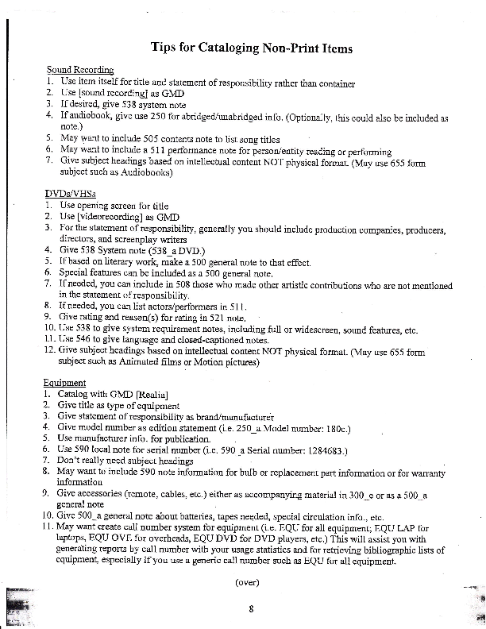

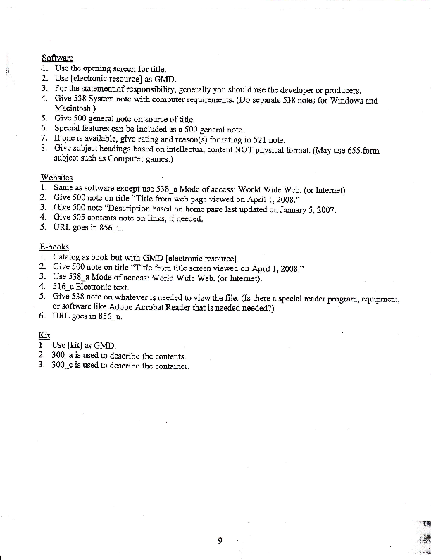

Subject Headings

Subject Headings are words or phrases that describe the content of the item and are used as
access points. When assigning a Subject Heading, ask yourself, “What is this item about?”

Subject Headings are controlled vocabularies that gather all of the material about a subject under
one authorized term. This helps the patron find all of the sources that they seek on a given topic.

There are three types of Subject Headings that are commonly used.

Library of Congress Subject Headings (LCSH)
- Extensive list, widely used
- Specific terminology
- Academic or Formal language
- Difficult for children to use

Sears List of Subject Headings
- Designed to meet needs of smaller libraries and collections
- Provides guidance to create local Subject Headings
- Fewer technical terms
- Not often found in copy cataloging

Library of Congress Annotated Card (LC/AC)
- More suited for children’s material
- Less technical terms
- Headings tend to be more general for the benefit of younger users
- Used often in school libraries
**Think of this as a compromise between SEARS and LCSH**

The type of subject heading used affects the Indicators one sees in a MARC Record. On the
MARC Record, Subject Headings are located in the 6XX fields.

The second indicator will be as follows:
_ 0 = LCSH
_ 1 = LC/AC
_ 7 with a subfield $2 = Sears

In our library you will most often see _0 or _1 as we use LCSH and LC/AC.

Authority Records

In the library system, it is crucial that titles, names, and Subject Headings are used consistently.
This will ensure that the patron is able to find all of the information that suits their search.

Authority Records are created to ensure consistency in Bibliographic Records.

Visit: http://authorities.loc.gov when looking for the Authority Record for a select term.

Be sure to only used Authorized terms when creating a MARC Record. Use Authorized terms
for fields with names and Subject Headings.

Vendor Information

Currently in Howard County, the vendors that provide the accepted processing are as follows:

Baker & Taylor, Inc
Perma-Bound
Scholastic Library Publishing

Materials ordered with the above companies come with the specific processing elements for HCPSS.

*Note- when placing book orders, a minimum of 80% must be from the above companies.

The following is in accordance with HCPSS Policy, found on the HCPSS Intranet:

When completing orders for these companies, follow these directions:

a) Orders are to be shipped to the individual school (use the school's IFAS Location #).
b) In the End Use field, enter Library Media Center.
In the Notes > Print After field, enter: "Please send vendor copy of PO to Media
Technical Services for mailing."
c) "Free shipping/handling" (NOTE: Shipping for Scholastic is free only if the order is over
$1,000.)
d) "Full processing for all titles FREE of charge"
e) Send two copies of the list of titles with the RQ# and the school name to Media Technical
Services: keep a copy of the list at the school for checking in the order and for audit purposes
(must be retained for three years).
f) When the books arrive, do not open the boxes until the cataloger in Media Technical Services
gives notification that the titles have been merged with the database.
g) After hearing from the cataloger at Media Technical Services, open the boxes and check the
items against the order list and packing slip.
h) If there are any discrepancies in the order/shipment, contact the Specialist for Media
Technical Services via CLC or phone (410.313.7036).

Further specific information regarding vendors can be found in the Library Media Handbook, available on the HCPSS Intranet.

Dewey Decimal Classification

The Dewey Decimal Classification (DDC) is used to organize our library. The system is very complex and takes quite some time to master.

The Dewey Decimal system classifies knowledge into 10 categories:

The 10 Main Classes of the Dewey Decimal Classification

000 Generalities
100 Philosophy, psychology
200 Religion
300 Social sciences
400 Language
500 Natural sciences & mathematics
600 Technology (Applied sciences)
700 The arts
800 Literature & rhetoric
900 Geography, history, and auxiliary disciplines

General Dewey Decimal Classification Information:

- Hierarchical structure- moves from broad to narrow within the 10 main classes
- DDC is found in either the full form or abridged form- we use the abridged form
- All Dewey numbers have three numerals- the first indicates the main class, the second indicates the division, and the third indicates the section. Additional numbers are added after a decimal point to give even more specific information about the item.
- *Note that in some libraries, Biographies will be classified as 92, and thus does not have three numerals.

Sometimes you will deal with items that cover a variety of subject areas. Here are four important rules to consider when using the DDC:

1. Rule of Application: If one discipline is acting on another, class the information package under the
discipline being acted upon.

2. Subject Receiving Fuller Treatment: If one subject is treated more fully than any of the other
subjects, assign number to the fuller subject.

3. First-of-Two Rule: Two disciplines being treated with equal coverage use the number that comes
first in the Schedule.

4. Rule of Three: Three unlike disciplines under one broader heading, classify under the first higher
number that encompasses them all.

*Above information on DDC rules taken from:
Catalog It! A Guide to Cataloging School Library Materials By Allison Kaplan and Ann Riedling

Applying Dewey DecimalClassification in Our Library

We use DDC to arrange our shelves in the library. Here is the basic set up of our shelves:

Main/Non Fiction Collection

The Main, or Non Fiction Collection, is located on the low shelving in the main area of the media center. Each line below stands for one shelving unit.

000’s-100’s
200’s
300’s
400’s
The 400’s 500’s and 600’s extend to the shelving along the media center wall.
600’s -700’s
700’s
800’s
800’s- 900’s
The 900’s then extend to the shelving along the nearest media center wall.

Biographies are housed along the low shelving on the wall in front of the computer lab, followed by the remaining 900’s along the wall of the second lab.

The Reference Section

The Reference Section is housed on the low shelves that are situated on an angle. They are located behind the computers in the main area of the media center. Each line below stand for one shelving unit.

Encyclopedias/Almanacs/Atlases
REF 900
REF 800-900
REF 700-800
REF 500-700
REF 300-500
REF 001-300

Fiction

Our Fiction collection is housed on tall shelves along the wall of the TV Studio. These books are arranged by author last name.

Story Collection

Our Story Collection is housed on low shelving along the wall of the teacher workroom. These too are arranged by author last name.

Magazines/Periodicals

These are located on the low shelving close to the leisure reading area. There are also magazines housed on the two magazine stands in this area. We keep these organized by title as well as issue.

Audio Visual Collection

These materials are located in the A/V closet, next to the telecommunications closet. They are organized by Dewey Number.

Professional Resources

These materials are located in the teacher planning room and are also organized by Dewey Number.

Equipment

Equipment is stored in the appropriate storage rooms. They are not labeled by Dewey, simply by EQ and the type of equipment.

Updates & Inventory

It is crucial that accurate records are kept to ensure an up-to-date and relevant collection.

Inventory:

      - Inventory should be taken at least once a year. Ideally, this should occur after the first half of the year, and at the end. Keeping track mid year will alleviate major inventory issues at the end of the year.
      - Aside from notifying students of owed materials, it is wise to send out notifications to staff as well. *Note that staff cannot check out for the summer if materials are still owed.
      - Acquisitions and withdrawals of materials must be kept up-to-date in order to ensure proper numbers for inventory purposes

Weeding:
    - Weeding should occur at least once a year.
    - About 5% of the collection should be weeded every year.
    - Weed materials that are: out of date, severely worn out beyond repair, have been replaced by other more high quality items, or have not been checked out.
    - Certain subject areas that are more time sensitive, such as computer or informational books on technology, should be given careful attention. Ensure that material is not very out-of-date- if so, the book should be weeded.
    - Weeded materials are boxed up and sent forth to a warehouse. Such information is provided by Central Office.

Processing & Repairing Materials

Processing:

*Note that the Media Technical Services processes and catalogs items before they arrive at each school.

The following information is found on the HCPSS Intranet:

All materials ordered through the office of Media Technical Services will be cataloged and processed by them before being sent to the schools. The processing should not be altered in any way. Particularly do not change the Dewey number or add numbers or letters. Questions regarding cataloging should be referred to Media Technical Services.

Bar code numbers, cards, pockets, and book jacket covers will be provided for all materials. Materials should be put into circulation as soon as possible.

When receiving new materials:
- Count the contents and verify with the packing list that there are no discrepancies. Also check that barcodes and Dewey numbers are present. It is also wise to verify the packing list with your order form.
  - If there are discrepancies, please note on packing list and follow instructions outlined in the Library Media Handbook and send forth information to Media Technical Services
  - If there are no discrepancies, move on to next bullet point
- Fill out appropriate signature sections on packing list and send a copy to Media Technical Services
- Stamp items with school library media center stamp
- Adhere any protective labels to barcode or Dewey number
- Ensure barcodes scan and come up in the system
- Prepare book to shelve
- Shelve book in appropriate location

Repairing Materials:

Sometimes, materials can be fixed in order to lengthen their shelf life. We have all of the needed supplies in order to do these repairs. Here are some tips:

*Note, when doing repairs, use wax paper above and beneath the book part that is being repaired in order to prevent glue damage.*

Basic Repairs Include:

Replacing a Missing Page:
- This can be fixed by using special adhesive. Ensure that the page will fit neatly into the book, if not, trimming may be necessary. Apply adhesive to page, then start at the top of the book and slip page down into book. This ensures it is snug against the center of the book. Close the book, set a weight on top, and leave to dry.

Torn/Cut Page:
- Use special adhesive and apply to damaged area. Align text, apply pressure, and wipe away excess glue. Close book, set weight on top, and leave to dry.
- If the damage is more severe, a patch may be needed. Make sure damaged section is appropriately aligned with the rest of the page. Brush special adhesive over the entire affected area. Cut book repair tissue and place over adhesive. Smooth out bubbles, close book, set weight on top, and leave to dry.
- At times, a cut in a page can be fixed with using the appropriate tape. Cut tape to size, and ensure there are no bubbles.

Other Repairs Include:

Mending Hinges
Mending Spines

Both of these are possible to do, but require a bit more time and energy than the repairs listed above.
The instructions for these repairs can be found in the provided book repair manual. Put these materials
aside temporarily until repairs can be made.

When to Rebind:
    - The book is out of print and still useful to collection
    - The book is expensive and in all around good condition

Discarding Materials:
- If repairs are vast and too extensive the item may be discarded
- If an item is damaged, take into consideration:
  - whether the item is a duplicate and the other is in much better condition,
  - the circulation of the item—is it frequently checked out?
  - the relevancy of the item—is it out-of-date?, do we have more current materials that can replace this one?

Preventative Steps to take to increase shelf life:
      - Use dust jackets or paperback covers for books
      - Reinforce Magazine bindings and page corners
      - For Kits- Include a list of individual pieces on outside of Kit to ensure all pieces are accounted for during check in/check out process
      - Reinforce corners, spine, and bindings on print materials
      - General Rule—it is always better to fix the problem when it first surfaces, rather than deal with a larger problem later on!

Bibliography of Cataloging Resources

The following resources are very helpful to consult for any further information.

For specific policies and procedures for HCPSS:

Library Media Handbook –hard copy available in Media Specialist’s office and electronic copy available on HCPSS Intranet.

For Dewey Decimal Classification Information:

An Introduction to DDC:
http://www.oclc.org/dewey/versions/ddc22print/intro.pdf

Abridged Dewey Decimal Classification and Relative Index, 14th ed. Dublin, Ohio:
OCLC, 2004.

For General Information on Cataloging:

Gorman, Michael. The Concise AACR2. 4th ed. Chicago: American Library Association, 2005.

http://www.ala.org/ala/aasl/aaslproftools/resourceguides/aaslresource.htm#C

For General Information on MARC Records:

http://www.loc.gov/marc/umb/

To view MARC Records created by the Library of Congress:

www.loc.gov

To view Authority Records:

http://authorities.loc.gov/

Our Union Catalog for HCPSS:

http://pac.hcpss.org/hcps/hcpsindex.htm

Information on Book Repair:

http://www.dartmouth.edu/~library/preservation/

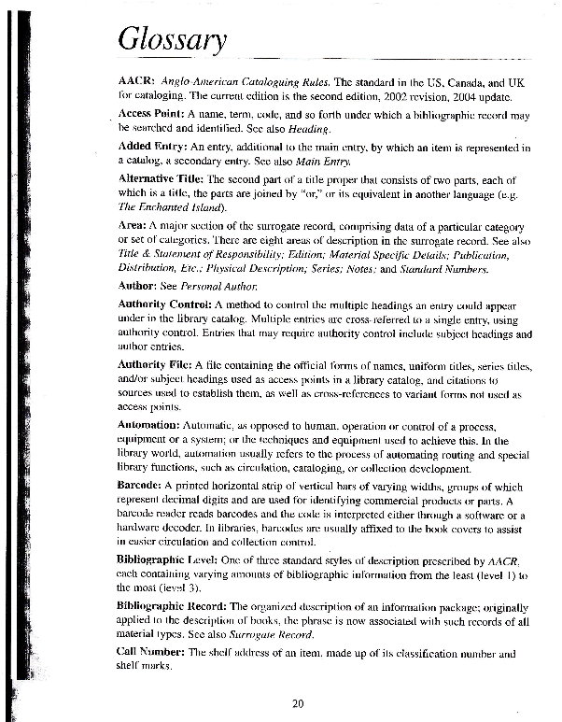

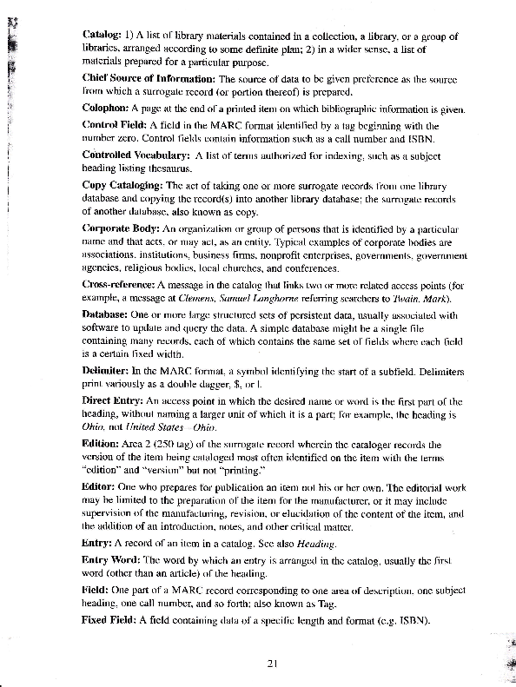
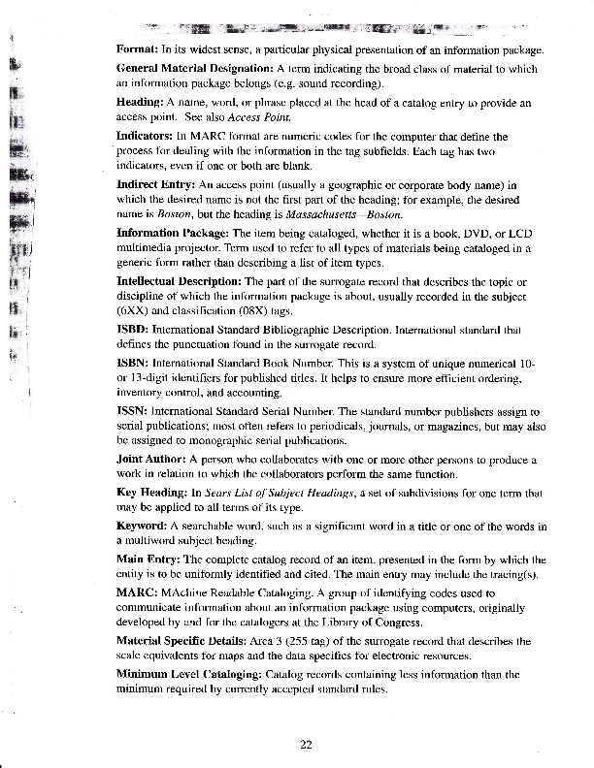

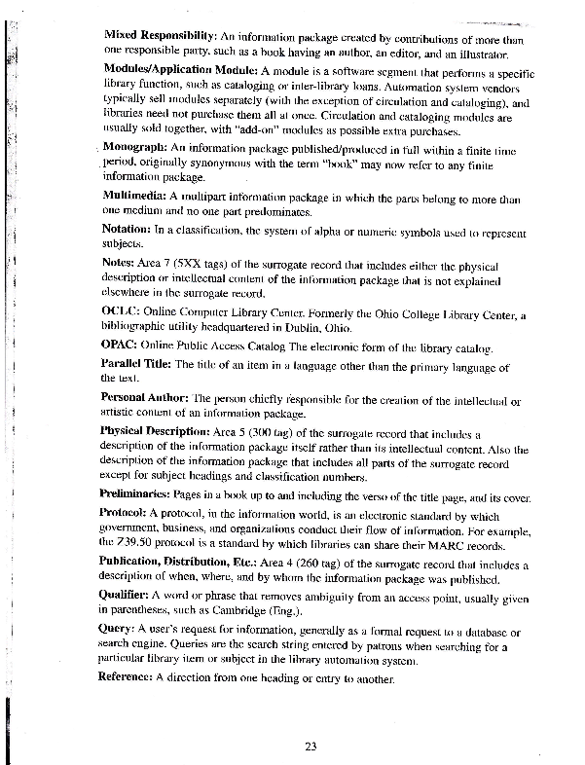

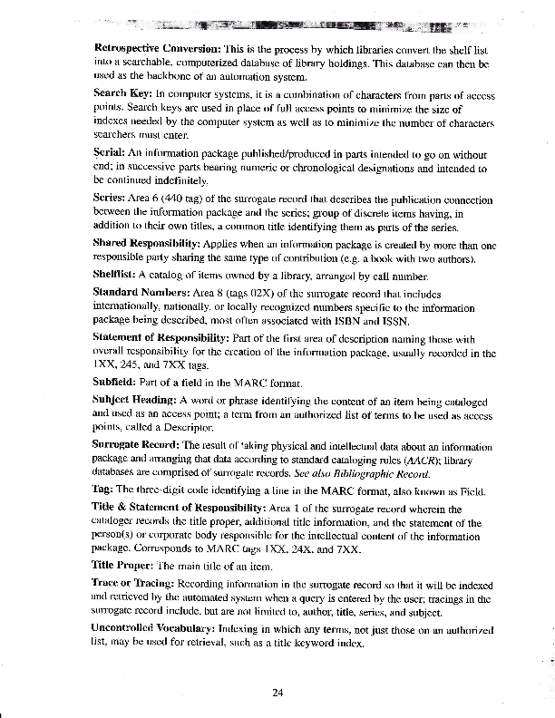

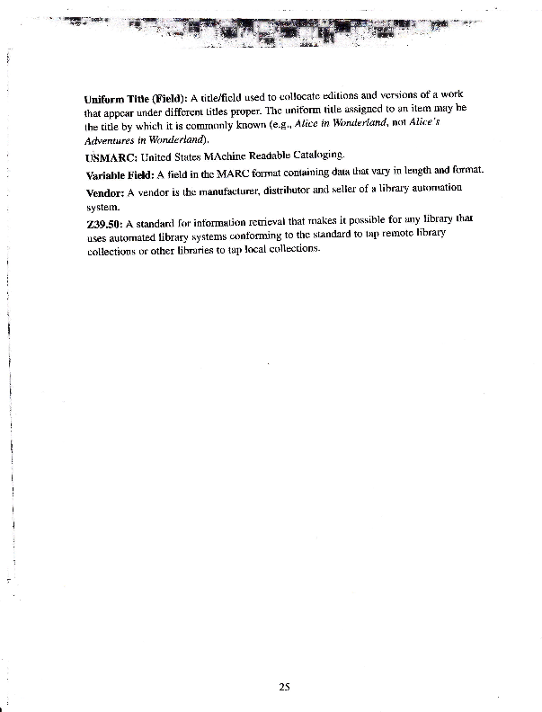

Lisa Tipton
SLM 502

Reflection

This assignment, and class as a whole, was a valuable learning experience for me. I truly feel that I have a deeper appreciation for the intricate workings in the organizational structure of a library. I came in to this course with virtually no experience with Dewey Decimal Classification or the slightest idea of the existence of bibliographic records. I always knew that source information had to be recorded somewhere in order for patrons to find their needed sources, but I had no idea as to what went into this task. This course showed me all of the careful detail and consideration that went into making our libraries a place filled with organized and accessible information.
I have learned how crucial it is for all patrons of a library, adults and children alike, to search for and locate information with ease (ALA Standard 4.1). In order for our patrons to have a successful experience at the library, the librarians or media specialists must ensure that the institution is organized and more importantly that such organization is maintained. Library collections must be monitored and records must be kept accurate and up-to-date. If this does not occur, patrons will be faced with a library that does not fulfill its goal- to provide free information in a way that is convenient to the user. In short, a library must offer a variety of information that reflects the needs of those in the world around us. Furthermore, such information must be laid out in a structured fashion to ensure comfortable patron use.
Even after providing a space in which patrons can be successful in finding their information, it is still up to the librarian or media specialist to play an active role in all that the library experience has to offer (ALA Standard 1.3). Librarians must not only be responsible for organizing the information, but also for knowing what their collection offers. Patrons must be able to turn to librarians and trust that they will be led to the answers that fulfill their questions. Librarians must actively work to ensure a collection that is easy to navigate as well as assist clients to locate the needed information. A positive library experience is the culmination of both a successfully organized system as well as the genuine effort put forth by the librarians to guarantee that knowledge can be obtained, digested, and ultimately result in creative thought.

