Name:
The Holocaust— A Controversial Issue?
Database Exploration

Topic Overview/Curricular Connection:

Congratulations on finishing the book Night by Elie Wiesel. It is a very powerful book that contains a strong message. Yesterday your teacher informed you that you will be researching controversial issues for your upcoming research unit. Believe it or not, the existence of the Holocaust is controversial throughout the world. Today you will practice using the databases by focusing on this issue.

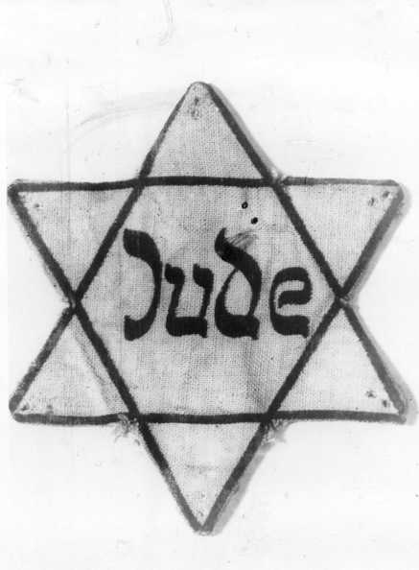
Below you will find two databases to utilize during your research. Please make sure you complete the given task for each step. Good luck!

Online Databases:

Although the school offers many databases, the following will be most helpful to you during your controversial issues research project. The databases are located at:
http://sites.google.com/site/rehsmedia/use-online-databases-and-reference-sources

For most of the databases if you log on at school, you do not need any usernames or passwords. If you need to access the databases from home, all information can be found on page 3 of your Agenda Book.

Please access and log on to the SIRS database.
Find the icon: and click on More Issues.

Use the index to locate Holocaust Denial.
Examine the page to answer the following questions:

1. What do the following symbols mean?

2. Locate the Essential Question. Write it down below:

3. Below, please give the title of one article that supports the YES column.

4. Below, please give the title of one article that supports the NO column.

5. How does putting this issue in the form of a question help to sort the sources?

Examine the layout of the entire page:

6. How is the page set up to help you, the researcher?

7. What do you think is the best feature on this page to help you find the needed
information?

Click on any of the articles from the page.

8. Explore the page and locate the MLA Citation. Please write the citation below:

9. When you read and take notes on a source, why is it important to write down the citation?

You can now exit out of SIRS. Go back to the RHS Reference Page.

Click on the Opposing Viewpoints Database.
Look at the upper right hand corner and find the search box. Type in Holocaust Denial and hit Search.

1. There are 6 categories for source types on this page. Write down the 6 below:

1. 2.
3. 4.
5. 6.

2. Now, click on the Issues tab at the top of the page. Scroll down to find the issue that you
chose for your controversial issues research paper.

Write down your controversial issue here: ___________________________________

Click on your issue to bring up the new page.

3. The top of your page offers an introduction to your topic. Below you will find the links to
many articles and other sources. Read through the introduction of your topic.

After reading your introduction, record 3 facts or pieces of information that you will
further research in order to incorporate them into your research paper.

Fact 1-

Fact 2-

Fact 3-

4. Locate the MLA Citation for your introduction. Write the citation below:

5. Think back to the SIRS database and compare it to this one. From what you saw today, do
you prefer one over the other? Why?

Please make sure that this worksheet is collected by your teacher or librarian.

You are all set to use the features of these two databases for your controversial issues research paper. Nice job!

