Children’s Literature
Annotated Bibliography

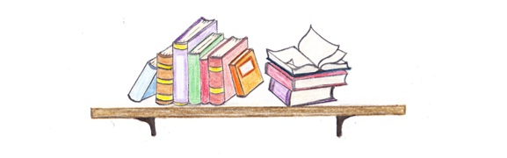

Lisa Tipton
SLM503

Table of Contents

Caldecott Winners and Picture Books...........................2

Newbery Winners and Intermediate Fiction..................7

Fairy Tales....................................................................14

Science.........................................................................18

Social Studies and Biographies.................................. .21

Maryland Black Eyed Susan Winners.........................25

Poetry...........................................................................27

Audio-Visual Books.....................................................29

Dear Readers,

I’m someone who likes to travel and learn more about the world around me. Since we all know how expensive vacations can be, I choose the next best thing—reading.

Books can take you to places you never dreamed of going. You can step back in time or flash forward into the future. You can witness real world events or journey on magical adventures. Best of all, you can do all of these things from the comfort of your favorite reading spot.

Who doesn’t want to become an expert on the people, places, and things that make up this interesting and beautiful world we live in? I know I do, and I hope you do too.

We all have different hobbies, different families, and different lives. But, no matter how different we are, each of us has the chance to get lost in a book and put our imaginations to work.

There are some great adventures out there, just waiting to be discovered, and in the end it’s up to you to find them.

~Lisa Tipton

Caldecott Winners
and
Picture Books

Bunting, Eve. Smoky Night. San Diego: Harcourt Brace, 1994.

Daniel and his mother watch the riots on the streets below. When they evacuate their building because of a fire, their cat Jasmine is missing. It takes the fire for everyone to act like true neighbors.

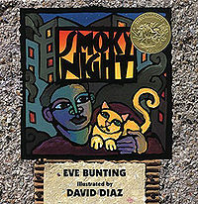

Burton, Virginia Lee. The Little House. Boston: Houghton Mifflin Company, 1942.

The little house has a wonderful life. She lives in the country and loves to watch the seasons change. She wonders what it would be like to live in the city, until the city is built around her. Soon the little house is covered in dirt and no one notices her. This all changes when a woman sees the house and makes a very important decision.
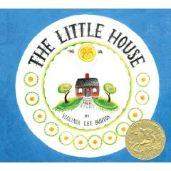

Gerstein, Mordicai. The Man Who Walked Between the Towers. Brookfield: Roaring Book Press, 2003.

Phillipe wants to walk across the space in between the Twin Towers. At nighttime, he sneaks in and sets up his tight walking ropes. The next day the crowds gasp as they see him walking high in the sky. Police gather on both towers, but no one is brave enough to walk on the rope to catch him. Though the towers are gone, Phillipe has created a memory that will last forever.
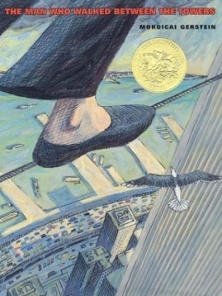

Henkes, Kevin. Kitten's First Full Moon. New York: Greenwillow Books, 2004.

Kitten thinks that the moon is the biggest bowl of milk she’s ever seen! She tries to chase it, but cannot catch it. She climbs the tallest tree she can find, but she still cannot reach it. She sees it in the pond and jumps in, but she only gets wet. Kitten is sad, but there is a surprise waiting for her when she gets home.

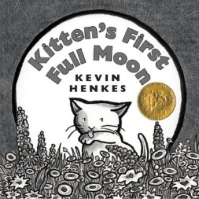

Keats, Ezra. The Snowy Day. New York: Viking Press, 1962.

All children love snow days! A little boy wakes up and plans a day of fun in the snow. He makes a snowman and wishes he could save the snow for himself. He takes a snowball into his house, but it melts. He is sad, but when he wakes up there is a big surprise waiting outside.

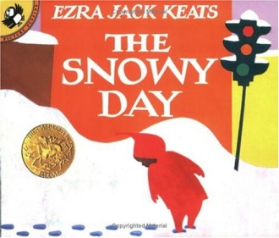

McCloskey, Robert. Make Way for Ducklings. New York: Viking Press, 1941.

With ducklings on the way, Mr. and Mrs. Mallard must quickly find a home. Mrs. Mallard teaches the ducklings how to swim and prepares them for their big journey to their new home. Mrs. Mallard leads the ducklings through town, stopping traffic on every corner. With the help of Officer Mike, they make it home safe and sound.

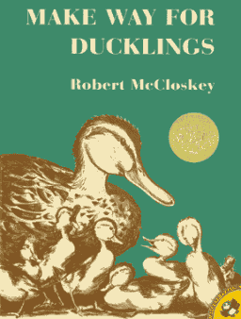

McCully, Emily. Mirette on the High Wire. New York : G.P. Putnam and Sons, 1992.

Mirette becomes curious when a lonely stranger comes to Paris. The man is the Great Bellini, a famous tightropewalker known for walking across Niagara Falls. He seems very sad and no longer wants to ropewalk. Mirette is determined to get Bellini to walk once again.
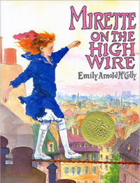

Rathmann, Peggy. Officer Buckle and Gloria. New York: Putnam and Sons, 1995.

When Officer Buckle gives safety tips at schools, the kids always fall asleep. He gets a dog, Gloria, who has a secret that kids love. Fan mail pours in until Officer Buckle finds out what Gloria has been
doing. It takes a pudding accident to show Officer Buckle that you should always stick with your best buddy.

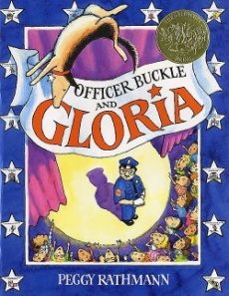

Rohmann, Eric. My Friend Rabbit. Brookfield, CT: Roaring Book Press, 2002.

Wherever Rabbit goes, trouble seems to follow. When his plane gets stuck in a tree, Rabbit comes up with a plan that involves all of the other animals. After Rabbit stacks the animals in a big pile, trouble is on its way. Come see what mess Rabbit has caused this time!

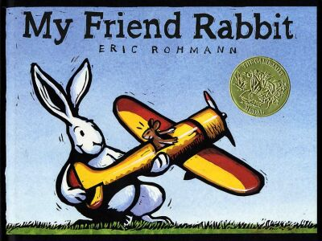

Selznick, Brian. The Invention of Hugo Cabret. New York: Scholastic, 2007.

When Hugo’s father dies, he leaves behind a journal with photos of an automated man. Hugo finds the man and fixes the machine. He then knows that the journal is a clue to unsolving a mystery. He and Isabelle work together and find the key that unlocks a big secret.
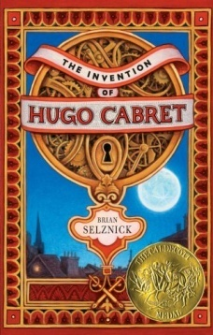

Taback, Simms. Joseph Had a Little Overcoat. New York: Viking, 1999.

Everyone has a favorite piece of clothing, and for Joseph it is his overcoat. When it gets too old to wear, he does not want to throw it away, so he recycles! He turns the coat into a vest. When that gets too old, he makes it into a scarf. Each time Joseph changes his old overcoat into something brand new.
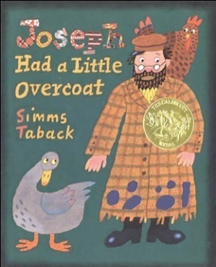

Van Allsburg, Chris. The Polar Express. Boston: Houghton Mifflin, 1985.

A young boy peers through his bedroom window, hoping to steal a glimpse of Santa and his famous sleigh. Much to his surprise, a train appears in front of his house. The journey begins to the North Pole to meet Santa. A special gift proves that always believing in magic and wonder ring true to the heart.

Wiesner, David. Flotsam. New York: Clarion Books, 2006.

A boy finds a strange camera with unbelievable pictures. They show mechanical fish, and even fish that can read. There is a whole world under the sea that no one knows about! When the boy finds a special photo, he becomes a part of this magical camera’s history.
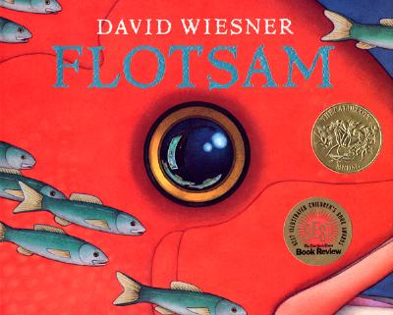

Wiesner, David. Tuesday. New York: Clarion Books, 1991.

On Tuesday at 8 p.m. some very strange things happened. Frogs on lily pads flew into houses, chased dogs and watched TV. The next day people found hundreds of lily pads in the street and wondered what went on overnight. Just wait to see what happens next Tuesday!

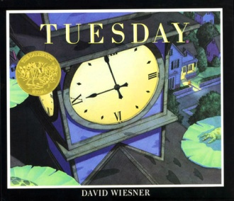

Young, Ed. Lon Po Po. New York: Philomel Books, 1989.

One day a wolf disguises himself as Grandma and tricks three children into letting him in their house. The children climb up a tall tree to escape. They trick him into climbing up for nuts they say will make him live forever. Can the children teach the wolf a lesson?
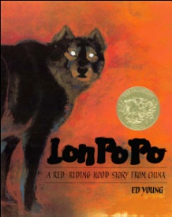

Zelinsky, Paul. Rapunzel. New York: Dutton Children's Books, 1997.

A horrible witch raises Rapunzel, a beautiful young girl. She locks Rapunzel in a tower with no door. When a prince discovers the secret to entering, he falls in love with Rapunzel. The angry witch sends her to wander the country alone, and causes the prince to go blind. Hopefully true love will win, and there will be a happy ending.

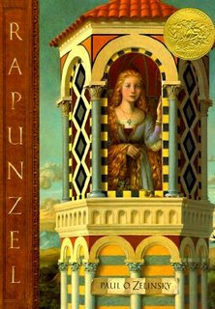

Newbery Winners
and
Intermediate Fiction

Avi, Crispin: The Cross of Lead. New York: Hyperion Books for Children, 2002.

After his mother dies, Crispin is left an orphan with nothing but his mother's lead cross. He is announced to be a wolf's head—free for anyone to kill! He meets Bear, a juggler and musician, who takes Crispin on a journey. When Crispin finds out who his true father is, he finally understands why the Royal family wants him dead.
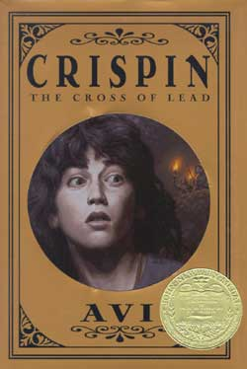

Cleary, Beverly. Dear Mr. Henshaw. New York: Morrow, 1983.

Leigh Botts is the new kid, with no friends but the school janitor. Leigh is sad that his Dad is always on the road, and his luck gets worse when the best part of his lunch is stolen at school. A class writing assignment gets Leigh to write to his favorite author, Mr. Henshaw, whose reply letters help to change Leigh’s life.
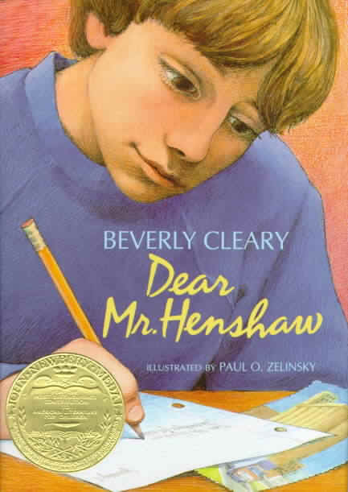

Creech, Sharon. Walk Two Moons. New York: HarperCollins, 1994.

Join Salamanca Tree Hiddle as she journeys west with her grandparents to visit her mother. On this ride, Sal talks about the dramatic Phoebe Winterbottom, who has her own personal lunatic, and the creepy Mrs. Cadaver, whose husband has disappeared. With all of these exciting stories, it will be a road trip you’ll never forget!
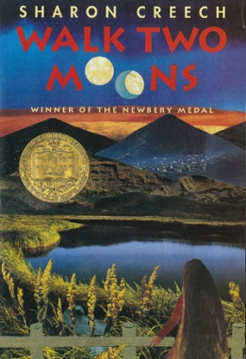

Curtis, Christopher Paul. Bud, Not Buddy. New York: Delacorte Press, 1999.

Bud Caldwell has had enough of mean foster families so he decides to hit the road. With only a photo of someone he thinks is his father, Bud sets out to find him in Grand Rapids. When he finally gets there and finds the man, Bud sees there really is somewhere he belongs.
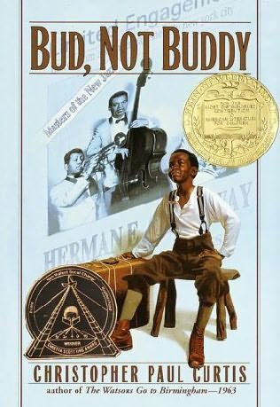

DiCamillo, Kate. The Tale of Despereaux. Cambridge, MA: Candlewick Press, 2003.

Imagine—a mouse that is too small to be a mouse, with ears too big for a mouse! Poor Despereaux is not your average mouse. He loves to read, listens to music, and falls in love with Princess Pea. When she is kidnapped, there is only one who has the most bravery to save her, no matter how small his size.
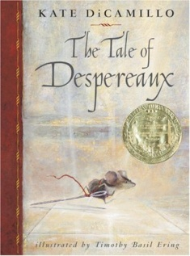

DuPrau, Jeanne. The City of Ember. New York: Random House, 2003.

Imagine living in a world of darkness where light bulbs are running out. In Ember, the people know that their city is dying and there is no hope for help. This all changes when Lina finds a piece of paper with clues for the escape from Ember. She and Doon set out on a journey to save Ember, and enter a new world full of light.

Fleischman, Paul. Joyful Noise: Poems for Two Voices. New York: Harper and Row, 1988.

Crawl into the noisy world of insects. Listen to angry worker bees tell about their daily life. Hear chirping grasshoppers and dizzy beetles share stories about their day. Come discover the sights and sounds of the bugs in the world around you.
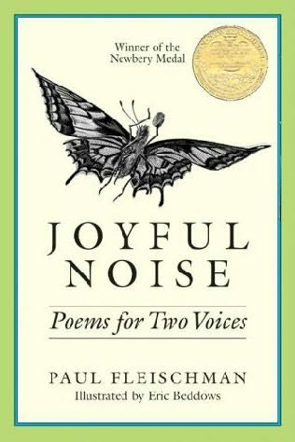

Fleischman, Sid. The Whipping Boy. New York: Greenwillow Books, 1986.

Imagine going from living on the streets to living in a castle! Jeremy is not a prince, but the whipping boy for when the prince gets in trouble. When Prince Brat forces Jeremy to run away with him, they are kidnapped by two foolish thieves. Jeremy knows that he can trick the men and escape, but the boys will have to switch places to do it.
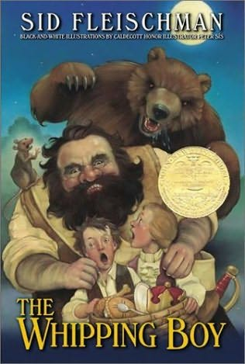

Gaiman, Neil. The Graveyard Book. New York: HarperCollins, 2008.

Nobody Owens lives in a world that most of us fear—one filled with ghosts, ghouls, and spirits. When his family is killed, the local graveyard adopts Bod and protects him from the evil Jack. The Graveyard is where the final battle between good and evil begins. Whether you’re a witch or human, fly to the graveyard for a night filled with “spooktacular” excitement.

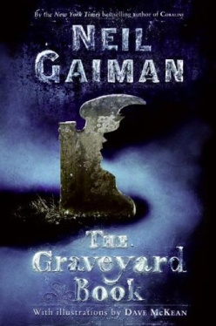

Haddix, Margaret Peterson. The House on the Gulf. New York: Simon and Schuster Books for Young Readers, 2004.

A great opportunity comes to Brit’s family when her brother Bran gets a job house sitting for the summer. Her mom can go to school, they can save money, and the beach is just four blocks away. When Bran begins to act strange, Brit starts to investigate. What she finds is a huge surprise and will make it a summer she’ll never forget.

Law, Ingrid. Savvy. New York: Dial Books, 2008.

Turning 13 is a big deal, especially in the Beaumont family. At 13 the children find their savvy, a magical power. Mibs’ father is in a terrible accident and she just knows that her savvy can save him. As she travels to the hospital, Mibs wonders if her family’s secret can be kept safe, or if she will have to let it out in order to save her Dad.

Lord, Cynthia. Rules. New York: Scholastic Press, 2006.

Catherine lives in a world full of rules. Her brother David is autistic and she helps him learn the rules of life. Catherine is stuck in between being embarrassed by David because he scares off friends, and having guilt about these feelings. It takes a new friend in a wheelchair to show Catherine that the biggest rule in life is just to live it.
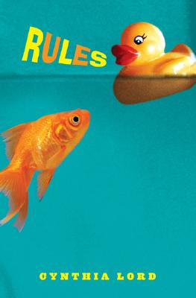

Lowry, Lois. Gathering Blue. New York: Houghton Mifflin Company, 2000.

After her mother dies, Kira is left an orphan. She is called to the Council of Guardians because she can weave beautiful colored patterns. Kira thinks she has been saved until she meets two other talented children, Thomas and Jo. Soon the three discover the Council of Guardians’ evil plan and set out to stop it.
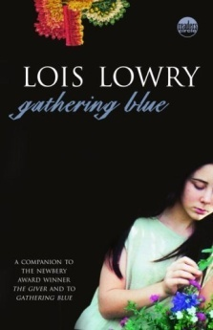

Lowry, Lois. The Giver. New York: Houghton Mifflin Company, 1993.

Jonas is 12 years old, the age when he receives his life assignment. Jonas is assigned the important job as Receiver of Memory. As he starts his training, he soon discovers that his perfect world is actually a nightmare. He wants to live in a world of color and freedom, so he makes a decision that will affect everyone forever.
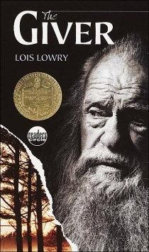

Lowry, Lois. Gossamer. New York: Houghton Mifflin Company, 2006.

When we sleep, we are visited by creatures who give us dreams. Littlest is a gentle dream giver, and is assigned to the house of a lonely old woman and angry boy. Littlest wants to make them happy and tries to give them wonderful dreams. All of this changes when the evil Sinisteed give the little boy scary nightmares. Littlest and others fight to save the boy before his nightmares ruin his life.
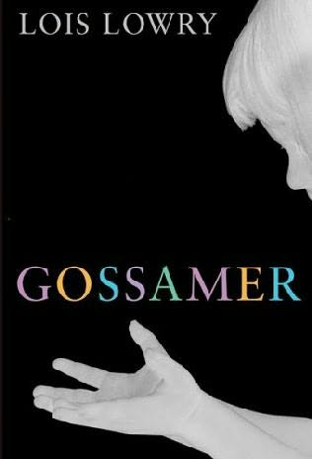

MacLachlan, Patricia. Sarah, Plain and Tall. New York: Harper and Row, 1985.

Caleb and Anna need a mother so their father sets out to find one. Then one day, the carriage brings home Sarah. As much as she likes her new family and home on the prairie, she misses the sea. After a severe storm Sarah learns that home is where the heart is.
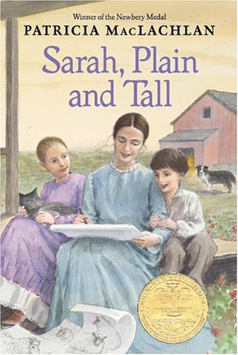

Naylor, Phyllis Reynolds. Shiloh. New York: Atheneum, 1991.

Life is just fine for Marty Preston, a boy who spends his days playing on the hills of his backyard. However the day he meets Shiloh, Marty knows life will be even better! Marty doesn’t want to return Shiloh to the mean Judd Travers, who will hurt the dog, not love him. Marty hides Shiloh, but the secret gets out. Only Marty’s bargain with Judd can save Shiloh’s life. Hopefully Marty is up for the challenge!

Paterson, Katherine. Bridge to Terabithia. New York: Harper Collins, 1977.

Jess can't wait to win the race at school, but he gets beat by a girl! Leslie shows Jess the magical world of Terabithia. They create fantastic stories and become the rulers of Terabithia. When tragedy strikes, Jess is left with only memories of these happy moments. Jess decides that no matter what, Terabithia will live on forever.
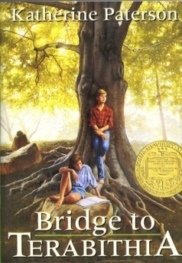

Paterson, Katherine. The Great Gilly Hopkins. New York: Harper Collins, 1978.

People always say ‘There’s no place like home’, but what if you don’t know where your home is? Gilly Hopkins is a misfit kid who bounces from foster home to foster home. She gets placed at Maime Trotter’s and writes to her mother to rescue her from this group of weirdos. However when the time comes to leave, Gilly realizes that you don’t need a family to have a true home.

Patron, Susan. The Higher Power of Lucky. New York: Simon and Schuster, 2006.

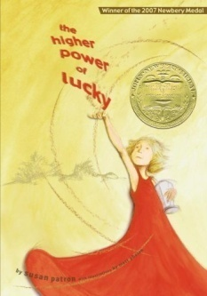
Lucky lives in the desert with her Guardian Brigette and dog HMS Beagle. She worries that she will be sent to the orphanage so she runs away during a sandstorm. Join Lucky as she finds her Higher Power, where she discovers that she truly is lucky after all.

Peck, Richard. A Year Down Yonder. New York: Dial Books for Young Readers, 2000.

After the Great Depression, Mary Alice is sent to the country to live with her Grandma. This Chicago girl thinks that her life will be terrible over the next year. Mary Alice soon finds that more excitement occurs with these locals than she first thought.

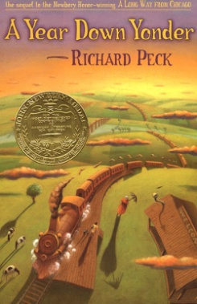

Sachar, Louis. Holes. New York: Yearling, 1998.

Stanley Yelnats is cursed because of his great-great-grandfather. He is sent to a camp for troubled boys for a crime he didn’t commit. Stanley finds that this camp is all work and no play, as the boys dig hundreds of holes in the desert every day. He soon discovers what the Warden is really searching for and how to break free of his curse.

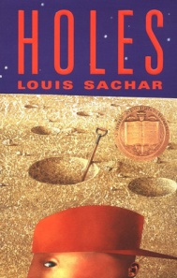

Schlitz, Laura Amy. Good Masters! Sweet Ladies!: Voices From a Medieval Village. Cambridge, MA: Candlewick Press, 2007.

Imagine living in a world with no TV, computers, or the Internet! Come find out what daily life was like in the Middle Ages. Hear from the sons and daughters of glassblowers, blacksmiths, royalty, and peasants. Think your life is hard? Try being a child in a Medieval Village!

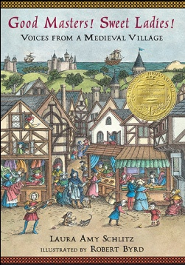

Spinelli, Jerry. Crash. New York: Random House, 1996.

Crash Coogan is a 7th grade football star who always wins. When the nerdy Penn Web moves in next door, Crash loves to make fun of Penn and his turtle. As the school year goes on Crash sees that Webb has certain things that he may never have. Will our jock continue to crash his way through life, or will he slow down to find out what is really important?

Taylor, Mildred. Roll of Thunder, Hear My Cry. New York: Dial Books, 1976.

The Logan family lives during a very racist time. White people and black people go to separate schools and live in different parts of town. Cassie and her family see how much harm hatred can do when their neighbors are threatened and even burned to death. Cassie learns that only family, strength, and pride can stop hatred.

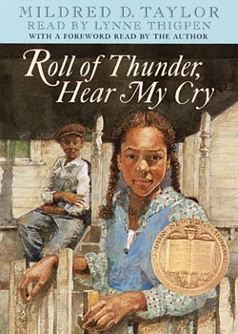

Fairy Tales

Deedy, Carmen Agra. Martina the Beautiful Cockroach. Atlanta, GA: Peachtree Publishers, 2007.

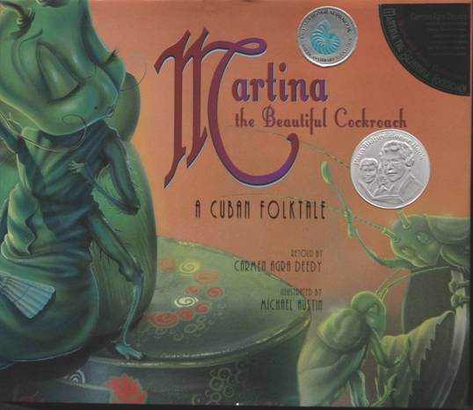
Martina the beautiful cockroach needs to find a husband. Many line up to marry her because of her great beauty, but she wants to marry for love. With the help of her Abuela and The Coffee Test, Martina sees the truth in each of her suitors. Only Perez, a tiny brown mouse, knows the way to win Martina’s heart!

Dorai, Gopal. Giraffes in the Savannah. Baltimore, MD: Shooting Stars Editions American Literary Press, 2008.

A long time ago, the giraffes in Africa were starving because there were no leaves to eat. The giraffes ask the Tree God to grow leaves that will feed them. The Tree God then has to ask the Mountain God to make rain for the trees to grow. However, the rain cannot come without the help of the Cloud God and Sun God. In the end, the giraffes learn how important each part of our Earth really is.
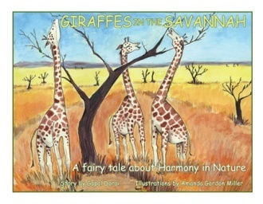

Eilenberg, Max. Beauty and the Beast. Cambridge, MA: Candlewick Press, 2006.

Living with two spoiled sisters can be tough. Beauty does not want rich gifts; all she wants father is a rose. Her father picks a rose that belongs to a terrible beast who wants to kill him. To save her father Beauty must live with the monster. She hates the beast for ruining her life but soon finds that even something hideous can be beautiful.
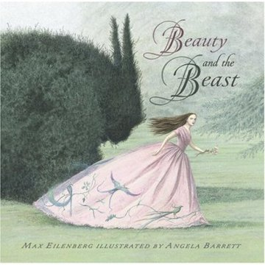

Fleischman, Paul. Glass Slipper Gold Sandal. New York: Henry Holt and Company, 2007.

Did you ever wonder what happens to Cinderella in Ireland or China? Cinderella is a very popular story throughout the world. In Japan she wears a beautiful red kimono to the ball, and in Iraq she wears gold sandals, not glass slippers. In some countries she leaves the ball on horse, or even in a carriage made of bread! No matter the country, all of the stories end the same—Cinderella finds her prince.
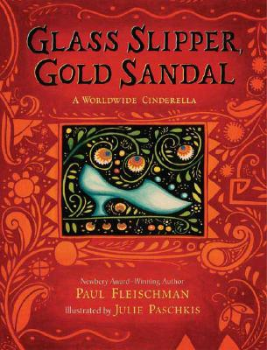

Fowler, Gloria. The Red Shoes. Los Angelos: AMMO Books, 2008.

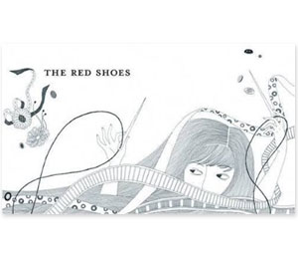
Karen’s mother is a creative shoemaker in their town. When she dies, all Karen has left from her mother is a pair of beautiful red shoes. One day a princess sees the shoes and wants them for herself. Karen must decide what she will do, give up the shoes and lose her mother’s memory, or come up with a plan.

Fox, Mem. The Goblin and the Empty Chair. New York: Beach Lane Books, 2009.

After a goblin sees his reflection in a pond, he decides he is too ugly to be seen by anyone. He lives a lonely life until he comes across a very sad family. At night he tiptoes to their house cleans, chops wood, and paints a fence. Goblin thinks that he has been sneaky, but the family has seen him. They invite him to dinner and Goblin has to decide whether to join, or remain in hiding forever.
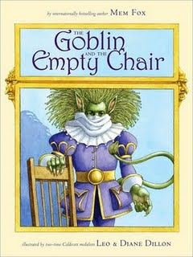

Lewis, Naomi. Hans Christian Anderson’s The Snow Queen. Cambridge, MA: Candlewick Press, 1996.

Kay falls under an evil spell and no longer wants to play with his best friend Gerda. The Snow Queen takes Kay to live in her empty ice castle so Gerda sets out on a journey to rescue him. With the help of a raven and a reindeer, Gerda makes it to the icy castle. It is up to Gerda to melt Kay’s icy heart and free him from the curse.
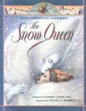

Perrault, Charles. Puss In Boots. New York: Farrar, Straus, and Giroux, 1990.

Puss is not your typical cat— he is very sneaky and loves to wear boots. He creates a plan for his master to become rich and marry the Princess. He orders peasants around, tricks a magical Ogre, and even fools the King. It is amazing that someone so smart loves to eat mice.

Pinkney, Jerry. Little Red Riding Hood. New York: Little, Brown and Company, 2007.

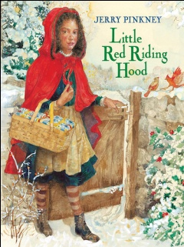
When Little Red Riding Hood went to visit her sick grandma, she had no idea that a clever wolf would ruin her day. The wolf tricks her into leaving the path to grandma’s house so he can get there first. When the girl arrives, what she finds isn’t her dear old granny, but a wolf with big ears and a very hungry stomach. Poor Little Red Riding Hood, if only she had listened to her mother!

Pinkney, Jerry. The Nightingale. New York: Putnam Books for Young Readers, 2002.

Throughout the kingdom, the nightingale is known for her beautiful songs. Even the king wants to meet this special bird. He loves her songs and she sings to him every day. The king receives a mechanical singing bird as a gift and the nightingale is forgotten. When the king needs help, it is only she that knows how to save him.
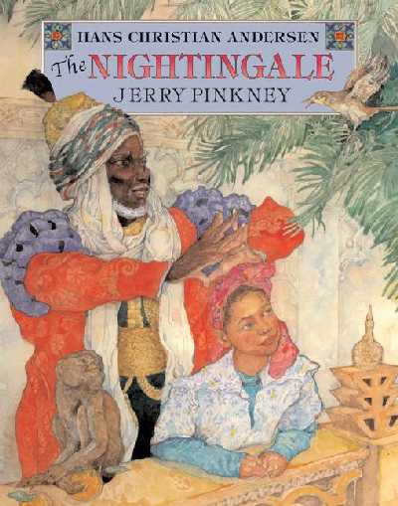

Schlitz, Laura Amy. The Bearskinner. Cambridge, MA: Candlewick Press, 2007.

The devil bet a soldier to wander for seven years with a bearskin over his body. During the time, the man could not pray, bathe, or cut his hair. If he did, the devil could take the man’s soul. If the soldier won the bet, then he would be rich forever. Despite the man’s horrible appearance he was still kind to others. The soldier knew that he must stay strong in order to win the love of a woman, and his soul.
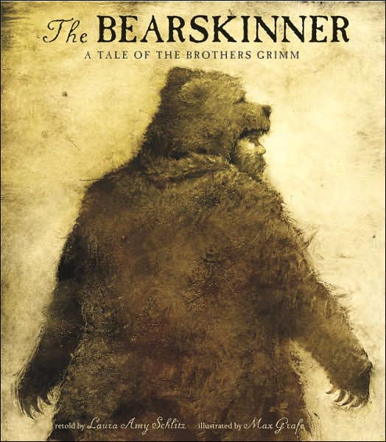

Young, Ed. The Sons of the Dragon King. New York: Atheneum Books for Young Readers, 2004.

The Dragon King has nine sons who live in separate parts of China. Rumors get back to the King that his sons are not acting as princes should, such as yelling at people and playing with fire. He decides that each son will do a job perfect for his own personality. Although centuries have passed, these jobs are still important to China today.

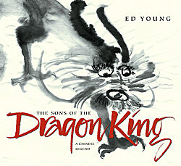

Science

Bishop, Nic. Frogs. New York: Scholastic, 2008.

Leave the human world behind and enter the world of frogs! Get an up close and personal look at these loud little creatures. Meet frogs that are as big as a baby and as small as your pinkie fingernail. Some are green or even see-through, but poisonous ones are blue and red. With so many things to learn, you should hop to it and start reading!

Bishop, Nic. Spiders. New York: Scholastic, 2007.

Many of us are afraid of spiders—after all they do have eight legs and eight eyes! There are more than 38,000 types of spiders in the world, and most of us have only seen those in our houses or backyards. Some spiders are very small, while others are larger than your hand. If you want to be really brave, get tangled up in this book.

Burleigh, Robert. One Giant Leap. New York: Philomel Books, 2009.

In July of 1969, an Eagle took the most important flight of all time. This Eagle was no bird, but the first spaceship with astronauts to land on the moon. Humans watched their televisions as Neil Armstrong and Buzz Aldrin opened the spaceship doors. People couldn’t believe their eyes as the men jumped around on the surface of the moon! It really was “one small step for man—one giant leap for mankind.”

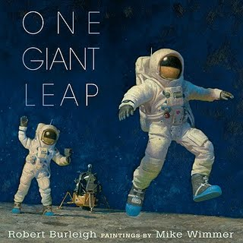

Deem, James. Bodies from the Ice: Melting Glaciers and the Recovery of the Past. Boston: Houghton Mifflin Company, 2008.

Imagine hiking on a snowy mountain and finding a human body. As ice melts, bodies that were frozen for hundreds of years are uncovered. Recently bodies of Incan children were found so perfectly frozen that they looked alive. As our planet continues to warm, who knows how many more bodies will be found?
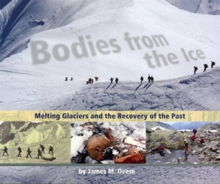

Gibbons, Gail. Tornadoes!. New York: Holiday House, 2009.

Clouds swirl, rain pours down, and winds whip things in the air—a tornado comes to life. Tornadoes happen in each of the 50 states and range from small destruction to EF 5’s, the most dangerous tornados of all. Cars, homes, and people are all at risk when a tornado strikes.
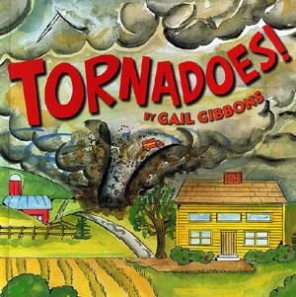

Hatkoff, Juliana. Looking for Miza. New York: Scholastic, 2008.

Did you think that only little kids can get lost? Well, little monkeys can get lost too! That is what happened in the Congo jungle of Africa to a baby gorilla named Miza. When a group of gorillas are forced to hide from hunters, Miza and her mom disappear. Park rangers and other gorillas search for Miza until she has returned, safe and sound.

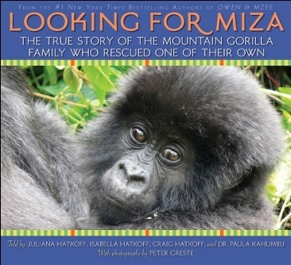

Hinshaw Patent, Dorothy. When the Wolves Returned. New York: Walker and Company, 2008.

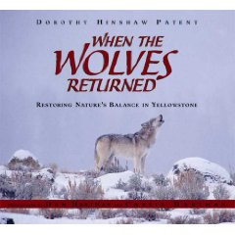
Everything in our world was created for a reason. When all of the wolves are forced out of Yellowstone National Park, the entire park is affected. As animal and plant populations move up and down, scientists see that removing the wolves was a big mistake. Come find out what happens when the wolves return to Yellowstone.

Montgomery, Sy. Quest for the Tree Kangaroo. Boston: Houghton Mifflin Company, 2006.

I know what you’re thinking, a kangaroo in a tree? Yes, it’s hard to believe, but it’s true! The tree Kangaroo lives in the forests of New Guinea. Travel with a group of scientists who put collars on these amazing animals to find out more about their lives.

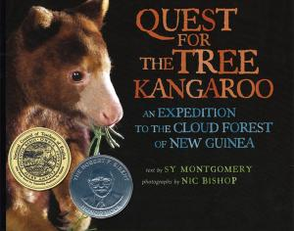

Montgomery, Sy. The Tarantula Scientist. Boston: Houghton Mifflin Company, 2004.

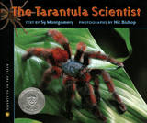
Creepy, hairy, fanged, scary. Those words describe one thing—tarantulas. Crawl into the world of these creatures and find out what their lives are like. Tarantulas come in all shapes, colors, and sizes. Tarantulas are amazing animals—did you know that their blood is blue or yellow, and they can even regrow lost legs? No need to be afraid of these critters, they don’t even want a nibble of you.

Scott, Elaine. Mars and the Search for Life. New York: Clarion, 2008.

Even though we can see Mars in our nighttime sky, very little is known about it. Scientists have been working since the 1960’s to send spacecraft to Mars. In 1976, Viking I and Viking II landed on Mars and took photographs that showed a dry and dead planet. Missions to Mars continue, in search of water and other signs of life. If we do find these things, one day human beings can live on Mars!
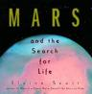

Social Studies
And
Biographies

Adler, David. Campy. New York: Viking, 2007.

Roy Campanella, or Campy, became the first African American Catcher in Major League Baseball. Fans loved him for his great spirit and kind soul. Everything changed when a car accident took away his ability to walk. Even though he could no longer play, Campy went on to change the game of baseball forever.
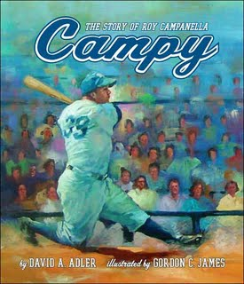

Birch, Beverly. Marie Curie: Courageous Pioneer in the Study of Radioactivity. Woodbridge: Blackbirch Press, 2000.

At a young age, Marie Curie was very smart and enjoyed science. She would grow up to be one of the most famous women scientists in the world. With her husband, Marie discovered radium—a powerful new element that would forever change science and medicine.

Bryant, Jen. A River Of Words. Grand Rapids, MI : Eerdmans Books for Young Readers, 2008.

William Carlos Williams was a doctor with a secret, he loved writing poetry. After a busy day, he would spend hours in his attic writing poems. They weren’t fancy and didn’t use big words. William wrote about food, colors, and trees—things that everyone can relate to.
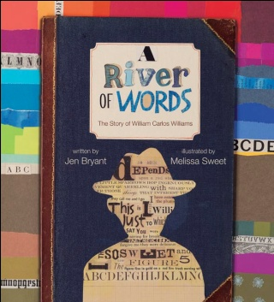

Freedman, Russell. The Adventures of Marco Polo. New York: Scholastic, 2006.

Is Marco Polo the “world’s biggest liar”? During the 13th century, he became one of the world’s most famous explorers. He claimed to have traveled all the way to China, and even became friends with ruler Kublai Khan. Polo wrote that he saw huge snakes with legs, and people who were covered in ink pictures. People didn’t believe his stories, even though he swore it was all true. Marco Polo—storyteller with a creative imagination, or great explorer? You decide.
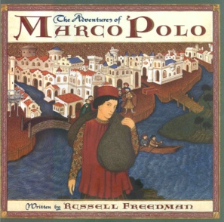

Gonzalez, Lucia. The Storyteller's Candle. San Francisco: Children's Book Press, 2008.

In New York City Spanish people could not go to the library because they didn’t speak English. Hildamar and Santiago feel the same until librarian Pura Belpre speaks to their class. She opens their eyes to what a wonderful place the library can be through her great stories.

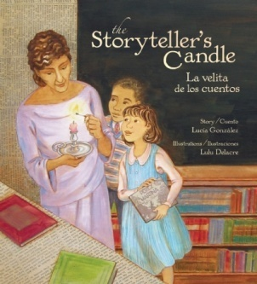

Kay, Verla. Rough, Tough Charley. Berkely, CA: Tricycle Press, 2007.

Charley Parkurst was an orphan who liked horses much better than people. Charley became the best stagecoach driver of the time and was known for the ability to scare off bandits. When Charley died, the old West was shocked by the secret kept for all those years.
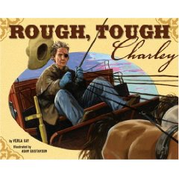

Kerby, Mona. Frederick Douglass. New York: A First Book Franklin Watts, 1994.

One of the most important people in history was born a slave. As a boy, Frederick Douglass broke the rules and learned how to read. He worked hard in the fields and was whipped by his white masters. However, this did not break his hope to escape. With forged papers, he left the plantation and headed for his long journey to Freedom.
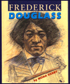

Kerby, Mona. Owney The Mail Pouch Pooch. New York: Frances Foster Books, 2008.

The Post Office once had a strange worker, a stray dog named Owney. He liked to sit on the mailbags, and growl at those who weren’t postal workers. He took many delivery trips by train, and even crossed the ocean by ship. Owney received medals from all over the world for his long career as the most loyal mail guardian.

Kerley, Barbara. What To Do About Alice? New York: Scholastic, 2008.

Poor President Roosevelt! As if being President weren’t enough, he had another huge problem—his daughter Alice. Alice loved to have fun and did very unladylike things such as sneaking out and dancing all night long. She traveled all over the world and people loved her everywhere she went. Even though Alice was not always well behaved, she lived life to the fullest.
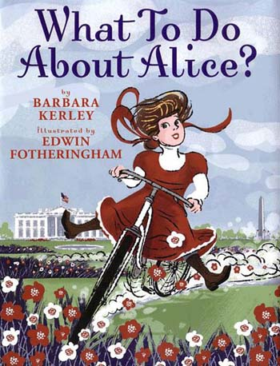

Murphy, Jim. Blizzard! New York: Scholastic, 2000.

In 1888, one of the biggest snowstorms in history hit the northeast United States. For three days, very strong winds and swirling snow made it dangerous to go outside. Thousands of people were trapped in trains, at work, or at home with no way to communicate. The storm killed many people who tried to hike through the snow. This blizzard forever changed how the United States viewed weather.
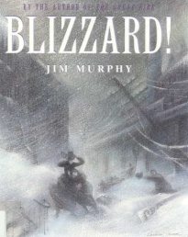

Murphy, Jim. The Great Fire. New York: Scholastic, 1995.

Chicago almost burned to the ground on a Sunday night in 1871. What started as a barn fire soon spread throughout the entire city—burning buildings and anything that came in its path. It seemed like the powerful flames would never stop.
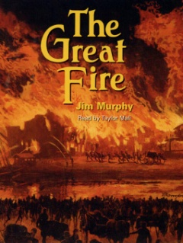

Nelson, Kadir. We Are the Ship: The Story of Negro League Baseball. New York: Hyperion Books for Children, 2008.

Before African Americans could play in Major League Baseball, they played in Negro Leagues. In the 1920’s, hundreds of men loved to play ball, but white people would not accept them on their teams. These players are heroes who fought for what they wanted, despite the hatred against them. Players today have these men to thank.
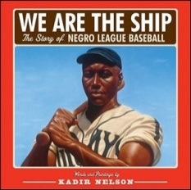

Scieszka, Jon. Knucklehead. New York: Viking, 2008.

Thousands of children love reading books by Jon Scieszka. He is always asked where he gets his ideas for his fun books. Well, when you grow up with five brothers, there is never a dull moment. There were sword fights, toys set on fire, wrestling, and lots of broken bones. Jon and his brothers really were the best knuckleheads around.

Maryland
Black-Eyed Susan
Award Winners

Clements, Andrew. No Talking. New York: Simon Schuster Books for Young Readers, 2007.

The fifth graders at Laketon Elementary School are so loud that they are called The Unshushables. The teachers don’t know what to think when one day the fifth grade is completely silent. No one is talking, not even at lunch or recess! To figure out what is going on, the teachers go to Dave and Lynsey, the leaders of this strange game.
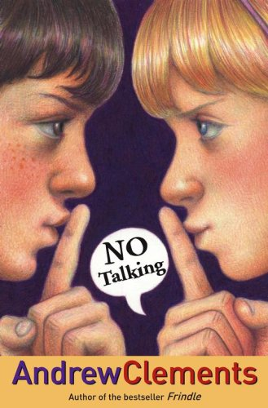

Stevens, Janet. The Great Fuzz Frenzy. New York: Harcourt, Inc., 2005.

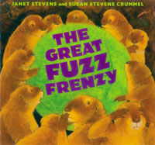
Prairie dogs were minding their own business, when THUMP, something crashed into their home. Whatever it was, it was green, round, and fuzzy! Soon each prairie dog wants his very own piece of fuzz. When it disappears overnight, frenzy breaks out as they fight each other for the fuzz. Hopefully they find the fuzz before someone gets hurt—it’s up to Big Bark to save the day!

Watt, Melanie. Scaredy Squirrel. Toronto: Kids Can Press, 2008.

Most of us have heard of Scaredy Cats, but have you ever heard of a Scaredy Squirrel? Poor Scaredy Squirrel lives in a nut tree and is too afraid to leave it. He thinks that tarantulas, killer bees, and green Martians will attack him. Every day Scaredy Squirrel does the same thing, until he knocks his survival kit out of the tree! He discovers something new about himself that makes him a little bit more brave.

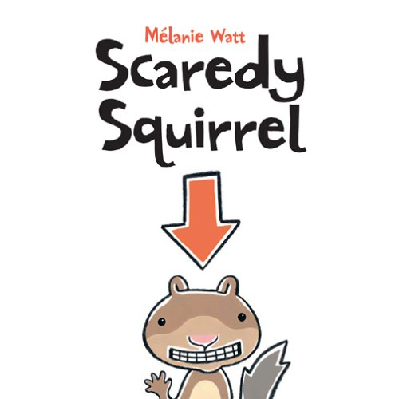

Poetry

Grimes, Nikki. When Gorilla Goes Walking. New York: Scholastic, 2007.

Gorilla isn’t a monkey, but a very special cat. Cecilia’s pet loves to walk outside and even answers the phone. Sometimes she’s happy, but other times she’s bad, like when she got paint everywhere! Even though Gorilla is crazy, she is Cecilia’s best friend.

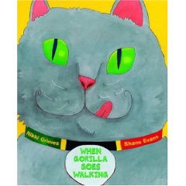

Hoberman, Mary Ann. You Read to Me, I'll Read to You Very Short Mother Goose Tales. New York: Little, Brown and Company, 2005.

We all know the nursery school rhymes of Mother Goose, but what if you could hear the stories from the characters themselves? Listen to Jack and Jill tell exactly how they fell down that hill. Hear from Humpty Dumpty and how a doctor tried to put him together using some tape! Come learn the true stories of your favorite characters.

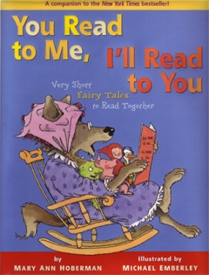

Hopkins, Lee Bennett. Days to Celebrate. New York: Harper Collins, 2005.

There are 365 days in the year and tons to celebrate. Discover the important people, holidays, and special events for each month. Read a poem by Langston Hughes to your mom on Mother’s Day. Celebrate the Fourth of July by reading about the Declaration of Independence. There sure is a lot that happens in a year!
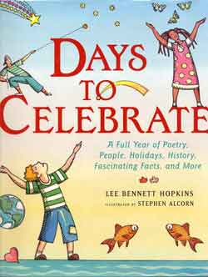

Hopkins, Lee Bennett. Hamsters, Shells, and Spelling Bees School Poems. New York: HarperCollins, 2008.

Elementary school is full of fun events! There is always something going on, from exciting spelling bees to special show and tells. So don’t miss the bus, your friends are waiting for you here at school!
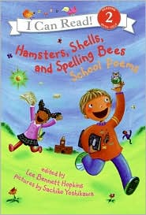

Hopkins, Lee Bennett. Oh, No! Where Are My Pants? New York: HarperCollins, 2005.

We have all had those days where nothing goes our way. These poems show kids who have had a few bad ones themselves. One kid had a day where he bit into an apple and swallowed a worm. One girl had a day where she got a really bad haircut, and another boy had his swimsuit washed away in the ocean. If you want to read about more terrible, horrible days, this is the book for you!

Kennedy, XJ. Elefantina's Dream. New York: Penguin Putnam Books for Young Readers, 2002.

Elefantina dreams of becoming a famous ice skater and winning the Elympics. At tryouts she completes the hardest jump by slipping on a banana peel! All that stands in her way is the same jump, but this time she’ll have to do it without the banana.
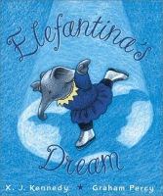

Audio-Visual
Books

Kasza, Keiko. My Lucky Day. DVD. G.P. Putnam’s Sons; Spoken Arts, 2003.

A wolf is thinking about dinner when a piglet rings the doorbell. Wolf grabs the piglet and starts to cook him for a tasty meal. The piglet tricks Wolf into giving him a bath, dinner, and even a massage before he escapes. That’s one lucky piglet, and one hungry wolf!
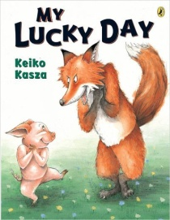

Keller, Laurie. Open Wide: Tooth School Inside. DVD. Henry Holt; Scholastic Video Collection, 2000.

Dr. Flossman teaches 32 young teeth how to keep themselves clean. They learn how to brush, floss, and rinse so they don’t become rotten. He even tells them a very scary story about the dangers of cavities. Hopefully the little teeth listen so they have a long, healthy life.

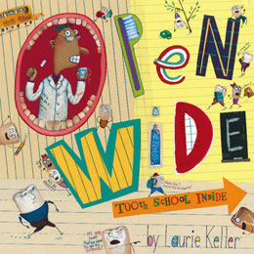

Manzano, Sonia. A Box Full of Kittens. DVD. Atheneum Books for Young Readers; Nutmeg Media, 2007.

Superman is Ruthie’s favorite hero and she wants to be just like him. When she spends the day with Aunt Juanita, she runs as fast as the speed of light to get whatever her aunt wants. Each time she rushes back because she does not want to miss the baby’s arrival. As Ruthie plays with three cute kittens, she misses her aunt’s call for help—the baby is coming! Can Ruthie save the day?
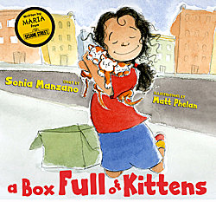

Reynolds, Peter H. The Dot. DVD. Candlewick Press; Scholastic Video Collection, 2003.

Vashti is having trouble in art—she cannot draw. Out of anger, she makes a tiny dot on her paper and the teacher hangs it up. She then draws nothing but dots—red dots, blue dots, small dots, and big dots. Everyone loves her art show, even if it is just a bunch of dots!
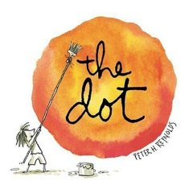

Scieszka, Jon. The True Story of the 3 Little Pigs! Narr. Paul Giamatti. Read Along CD. Viking; Weston Woods, 1989.

Poor Alexander T. Wolf—he was framed! Everyone thinks that he’s a bad guy, but he was just trying to make his dear old granny a cake. He wasn’t trying to blow down anyone’s house, he simply happened to have a huge sneeze. He swears—it was all just one big accident.

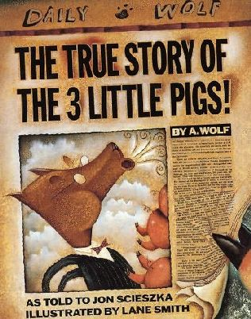

Willems, Mo. Knuffle Bunny. DVD. Hyperion Books for Children; Scholastic Storybook Treasures, 2004.

One day Trixie and her dad go to the Laundromat. She has fun putting clothes and money into the machine. On the way home Trixie can’t find Knuffle Bunny, her favorite stuffed animal. She tries to tell her Dad, but she can’t talk! She cries, screams, and throws a fit, but nothing works. Hopefully Mom can make everything better.

